# Normality Tests

## Plots for danceability variable

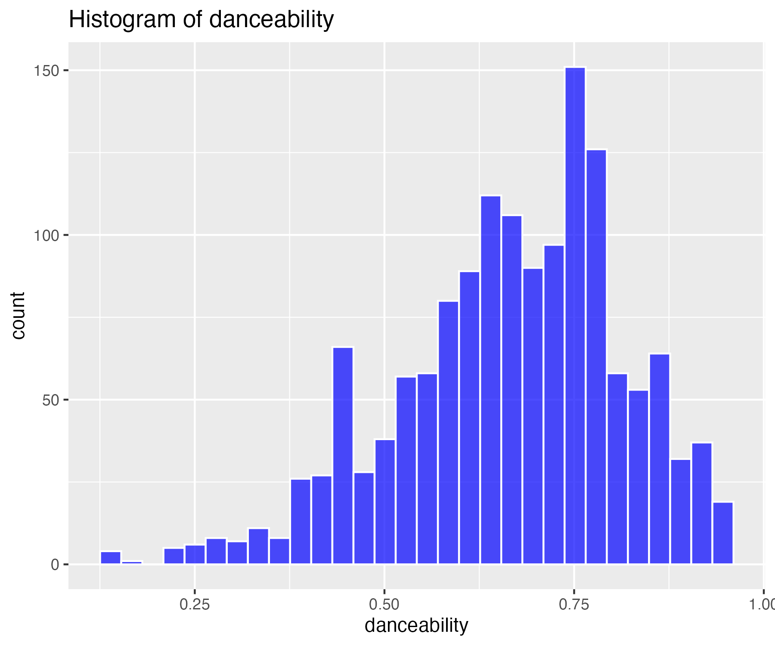

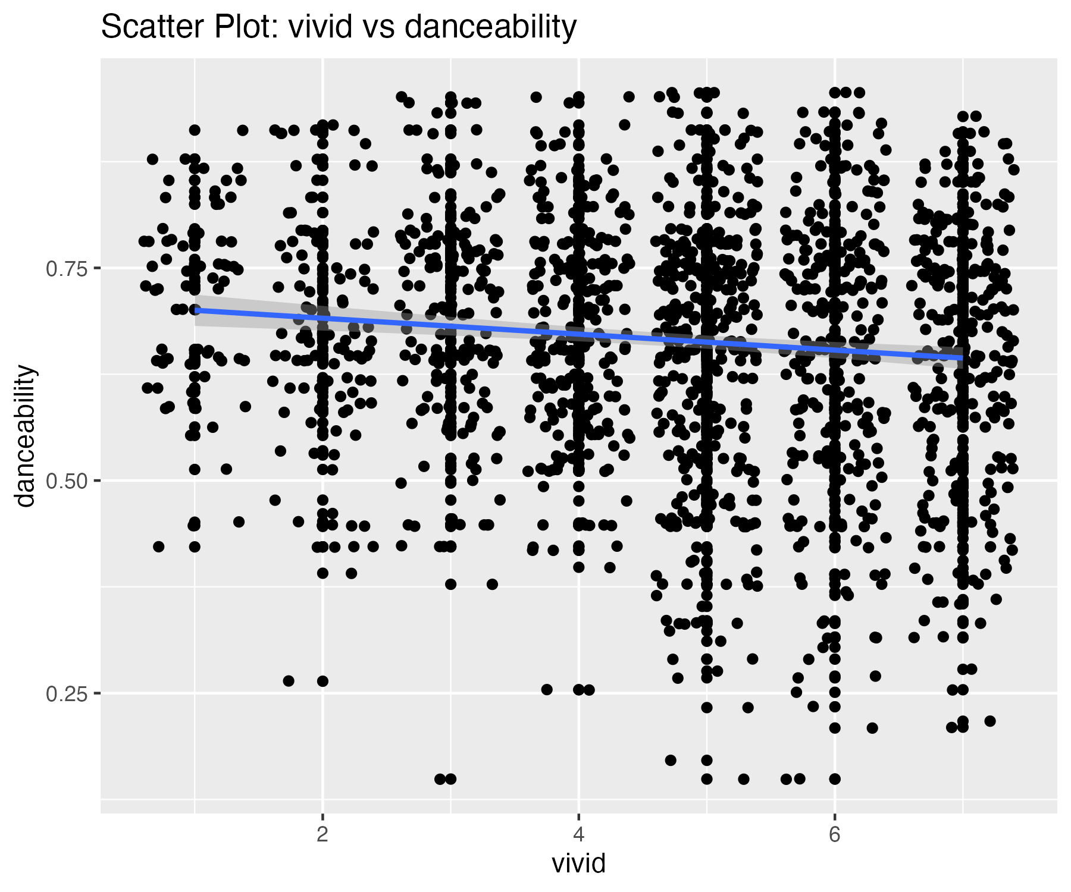

5 outliers were identified in the danceability variable.

## Scatterplot of danceability variable with outliers removed

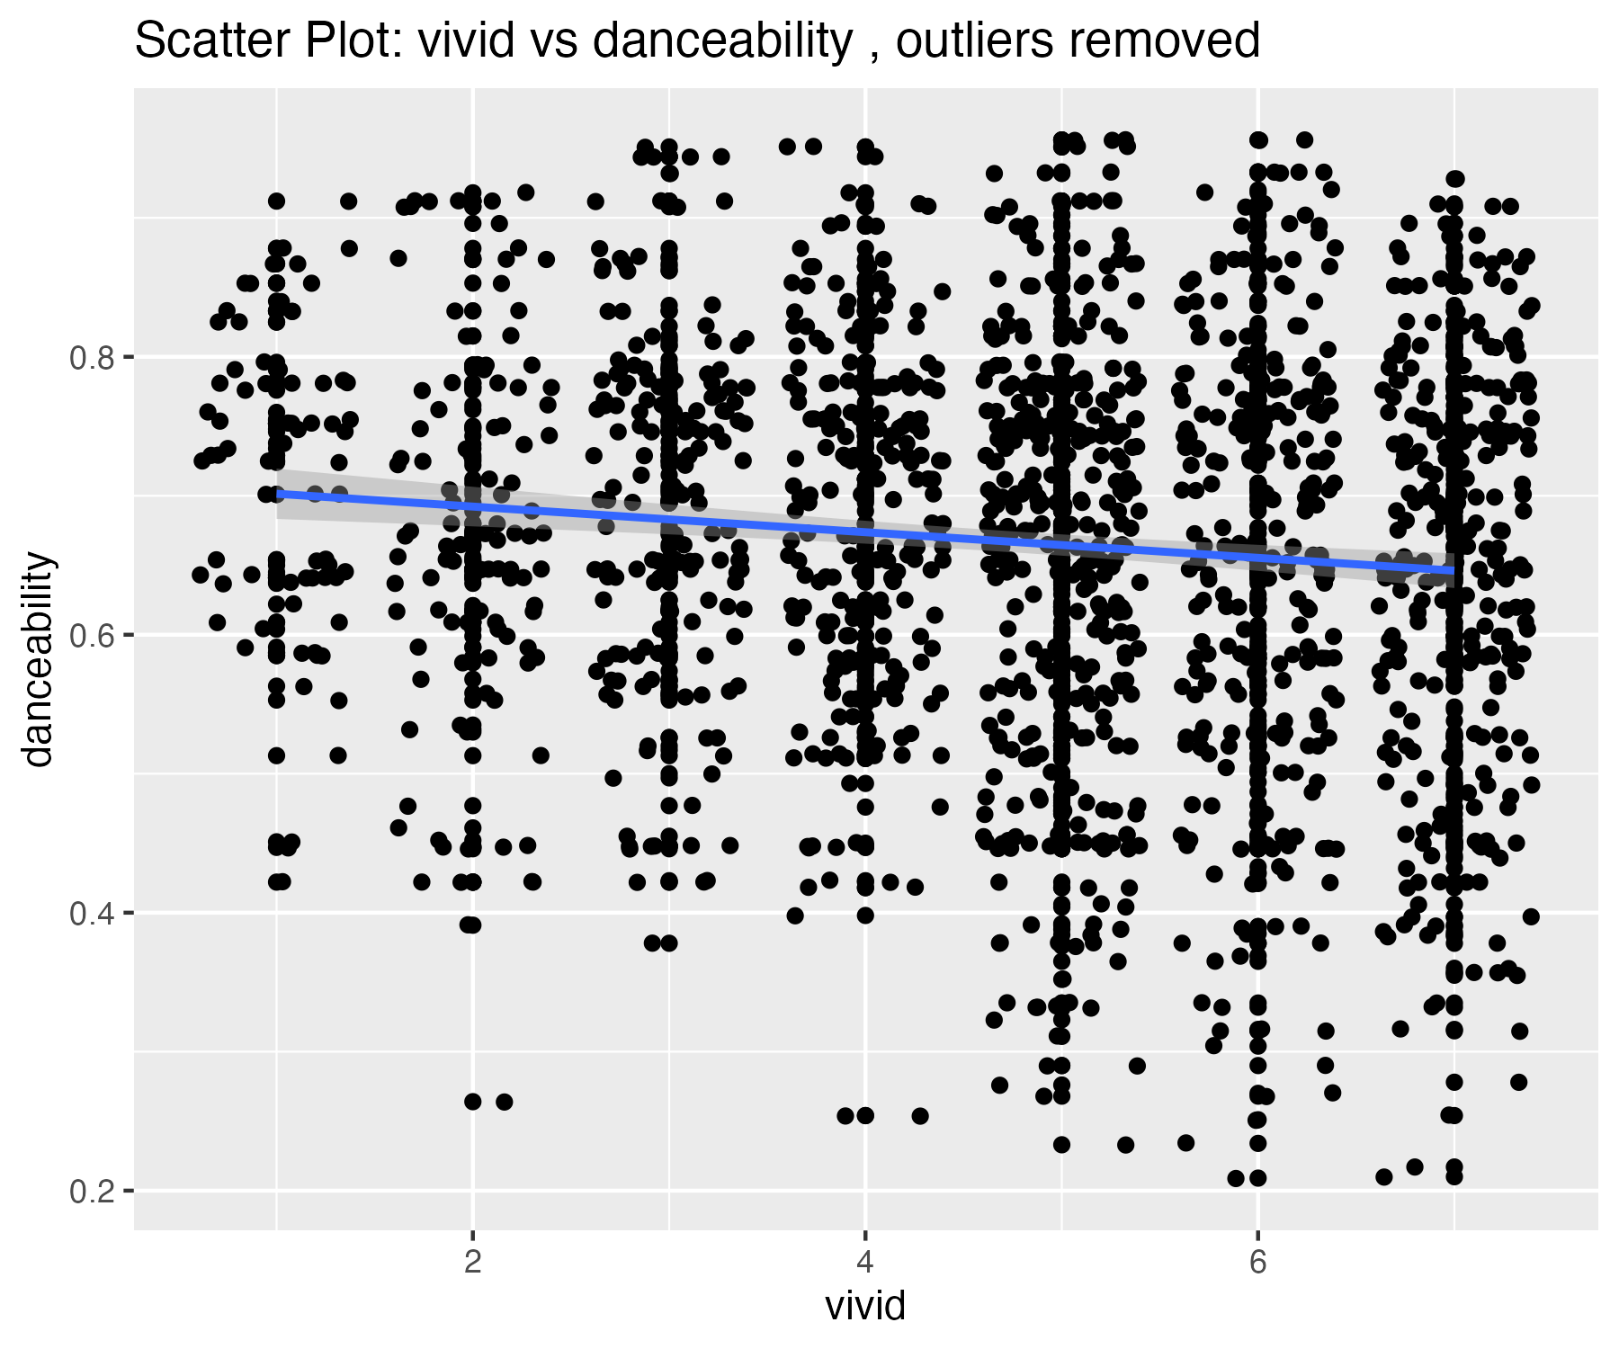

## Plots for energy variable

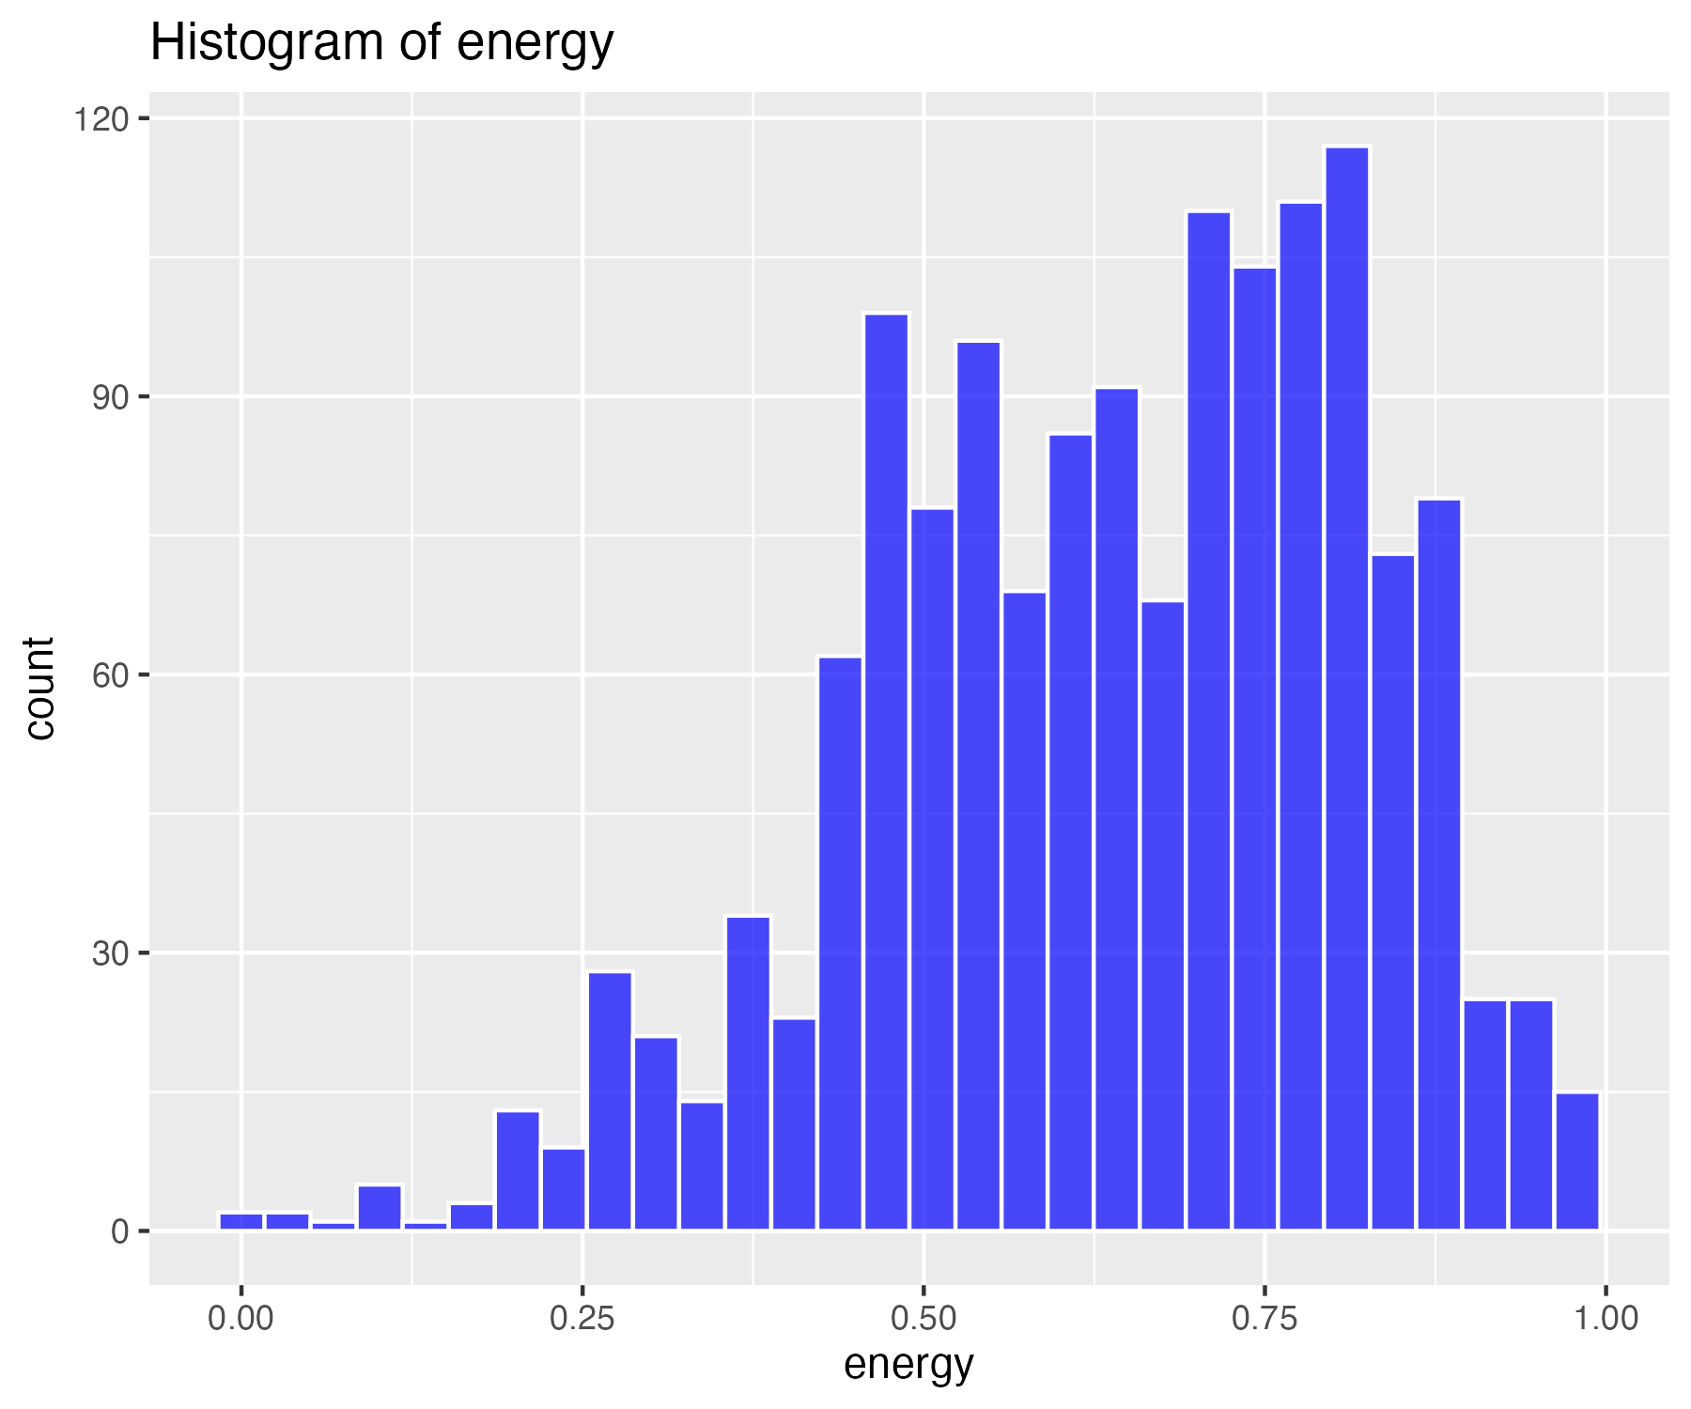

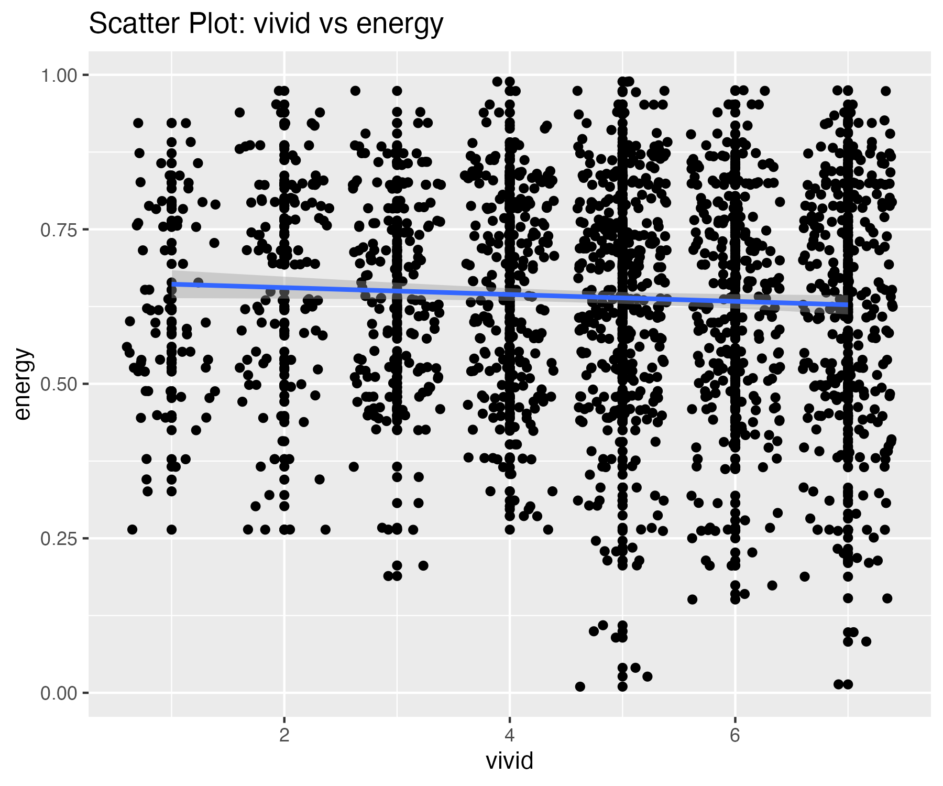

4 outliers were identified in the energy variable.

## Scatterplot of energy variable with outliers removed

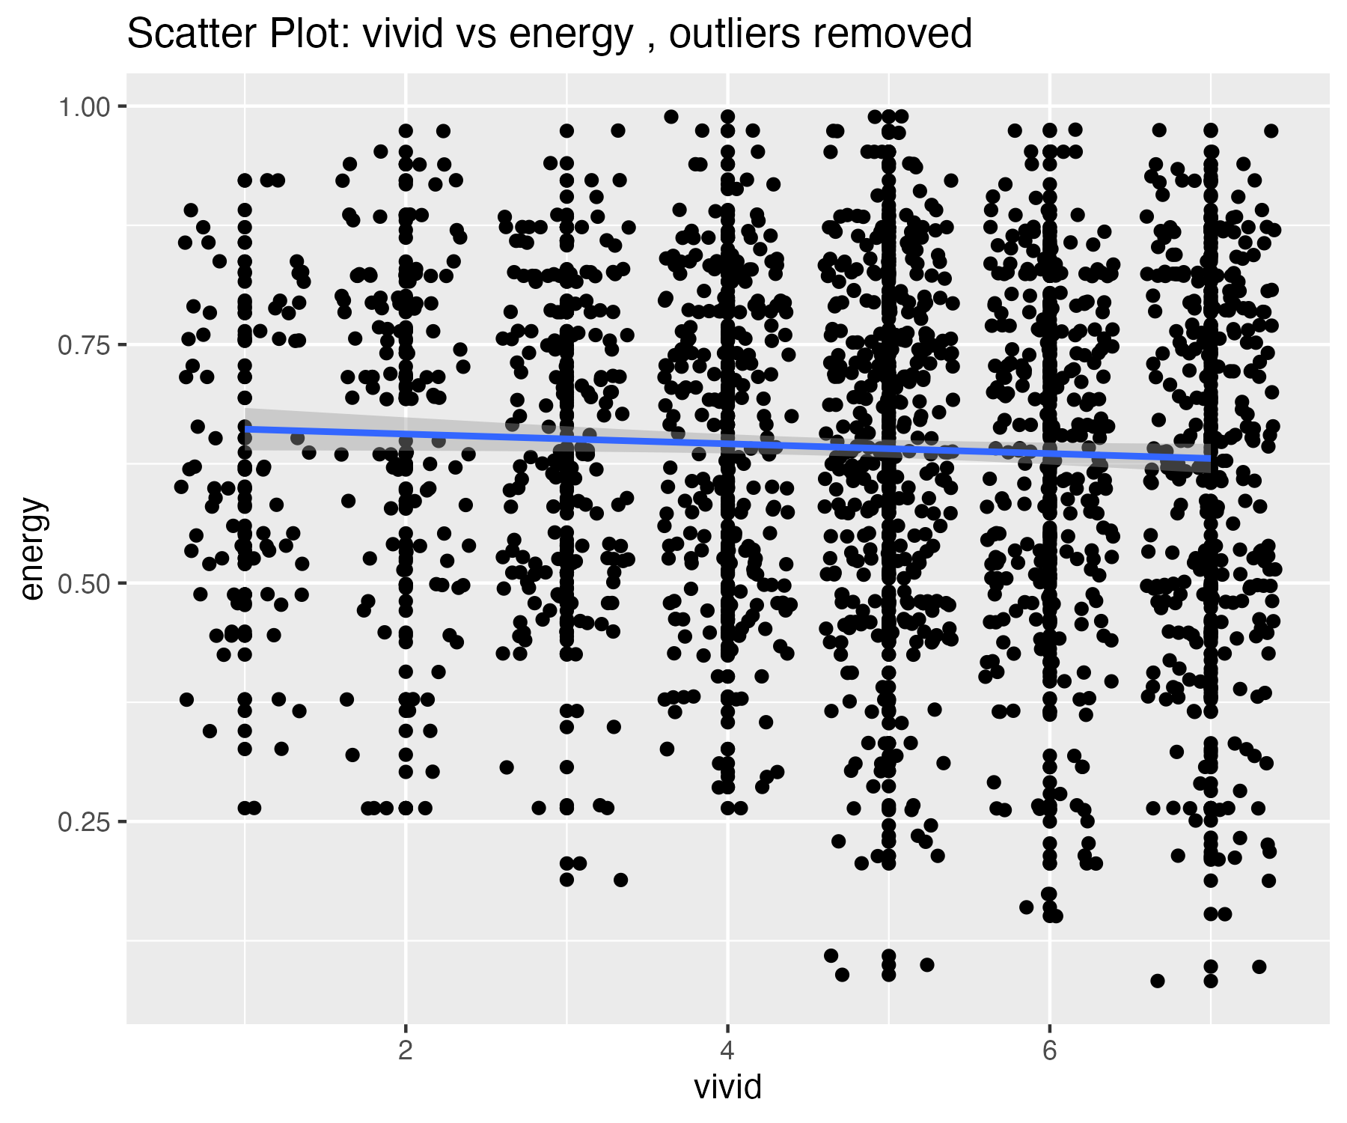

## Plots for loudness variable

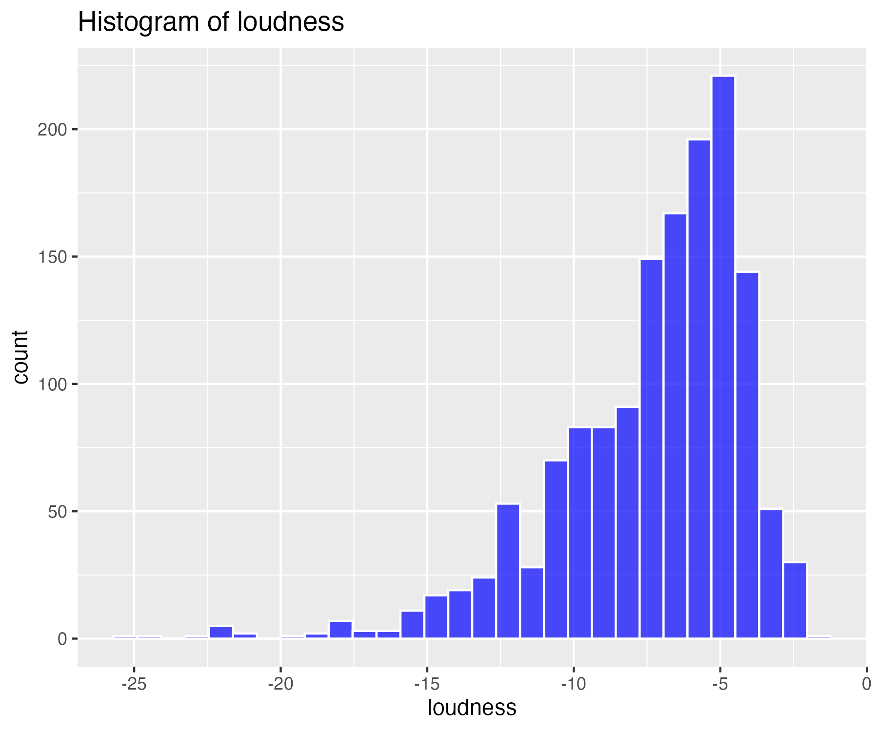

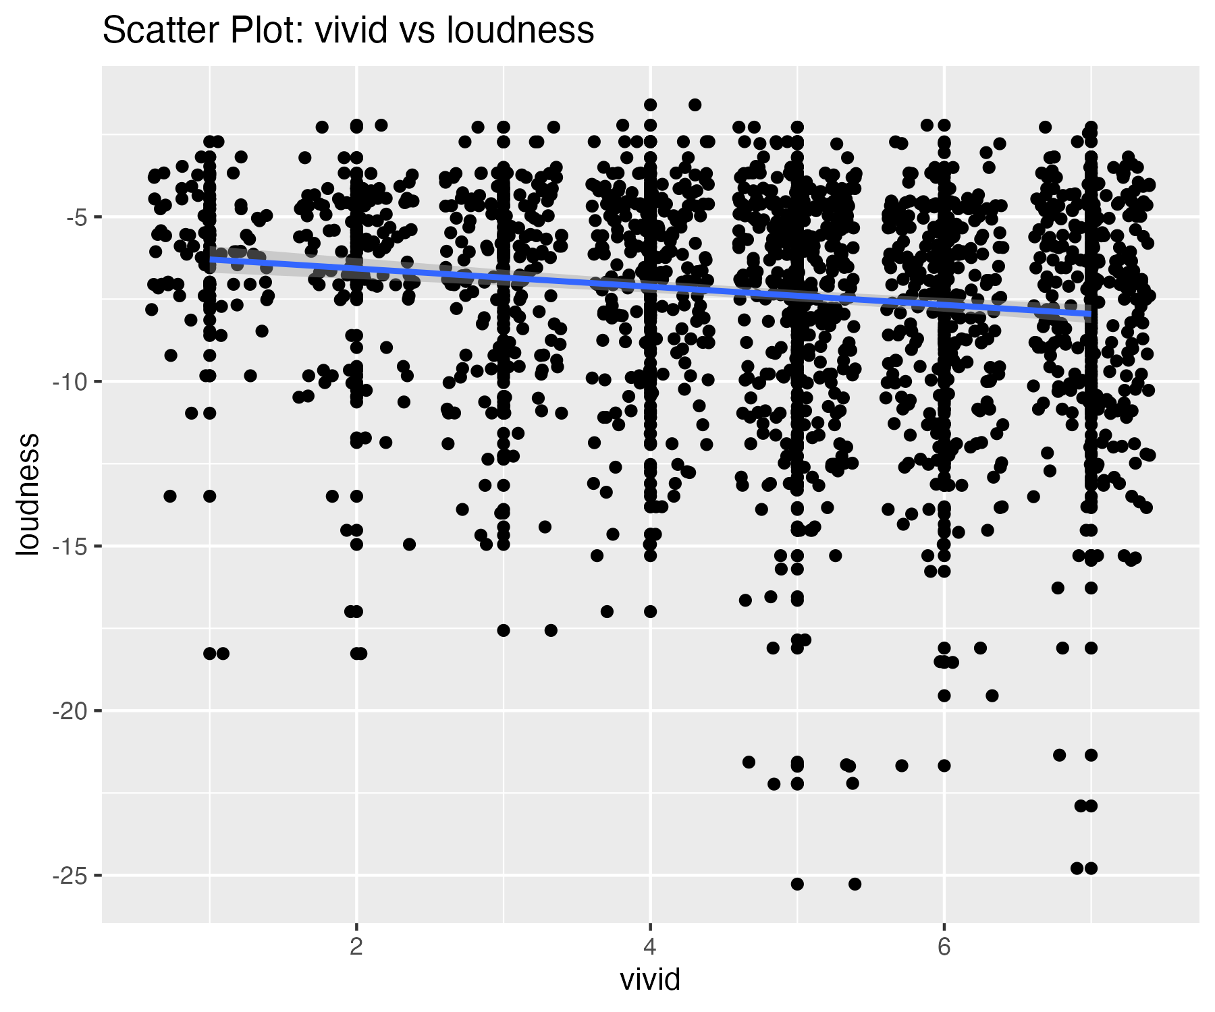

18 outliers were identified in the loudness variable.

## Scatterplot of loudness variable with outliers removed

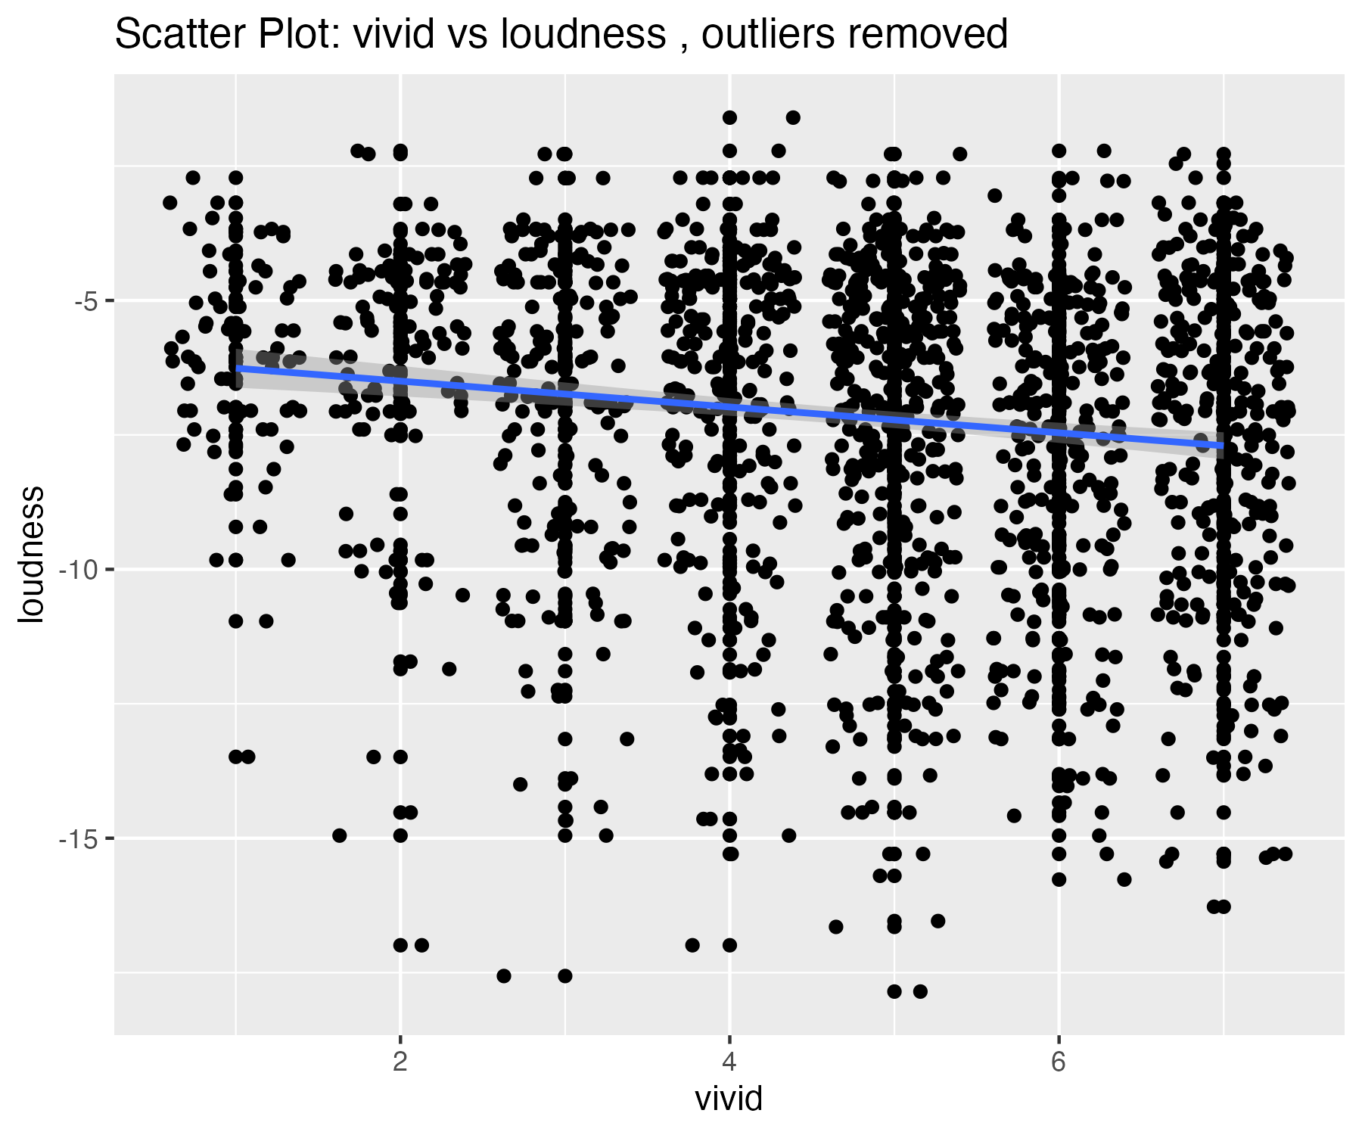

## Plots for speechiness variable

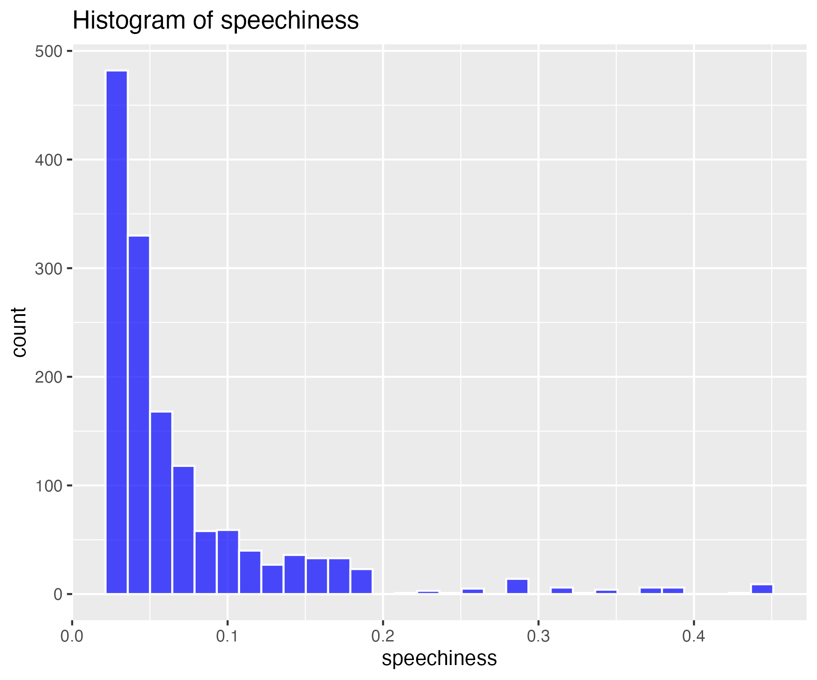

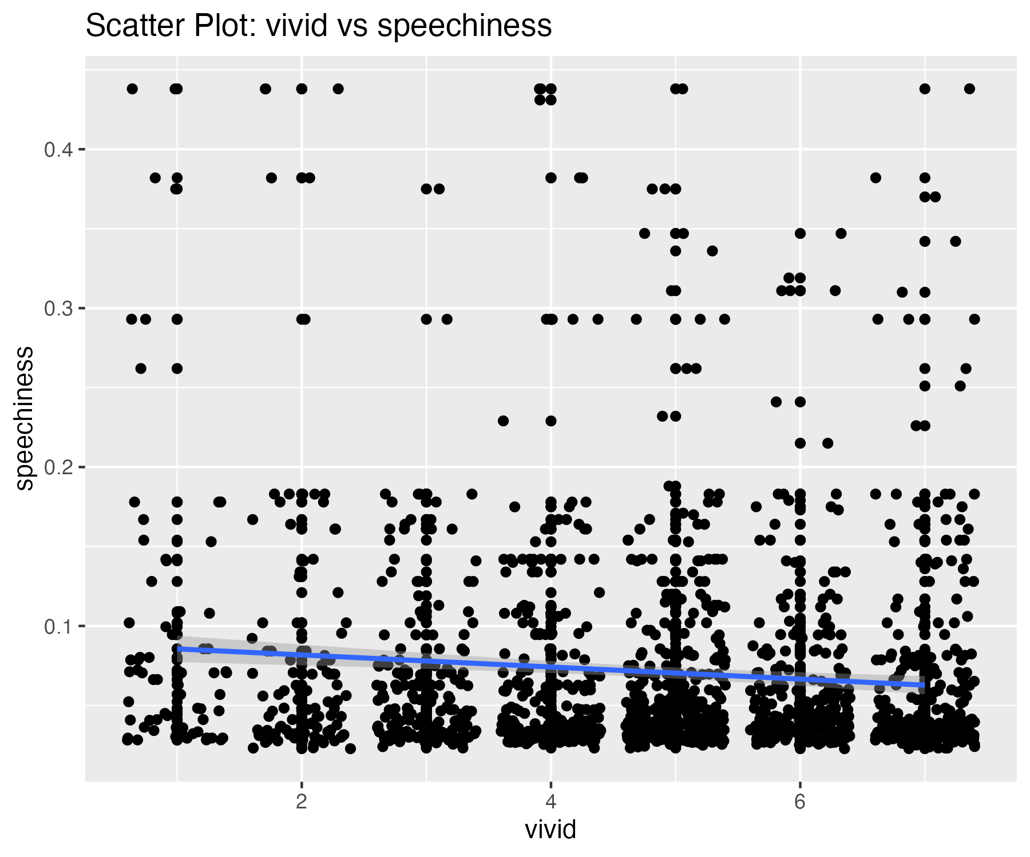

47 outliers were identified in the speechiness variable.

## Scatterplot of speechiness variable with outliers removed

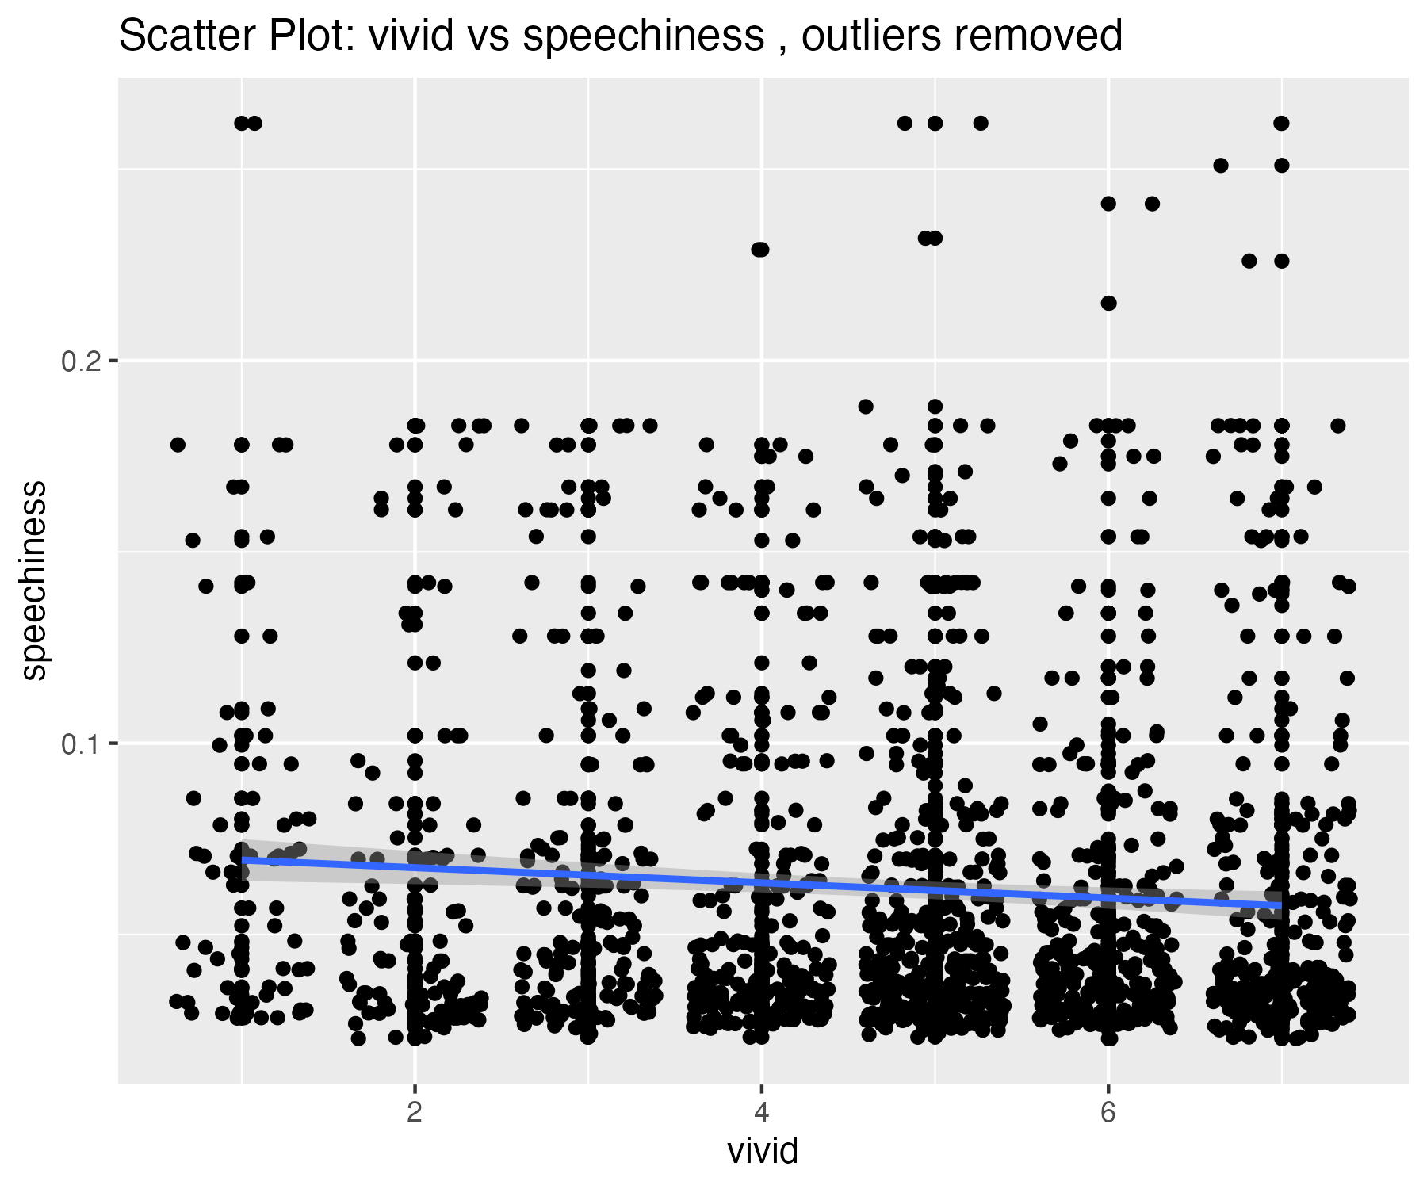

## Plots for acousticness variable

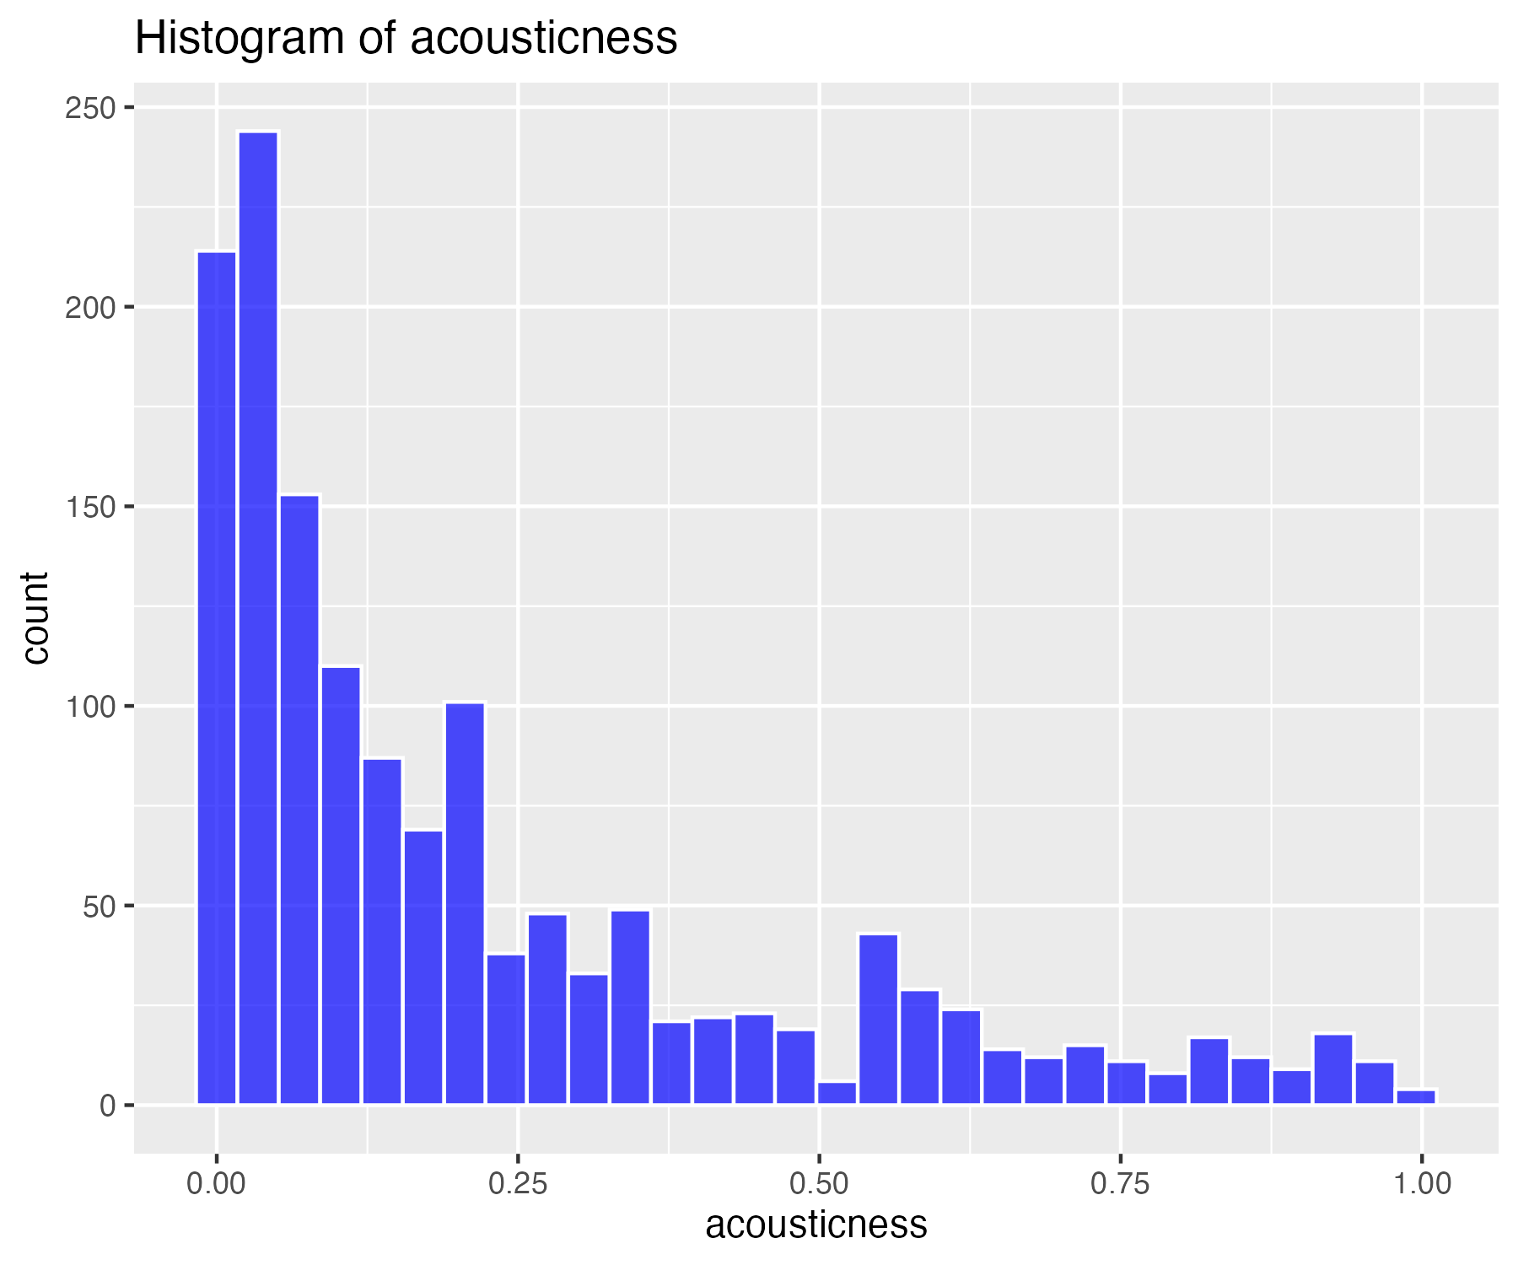

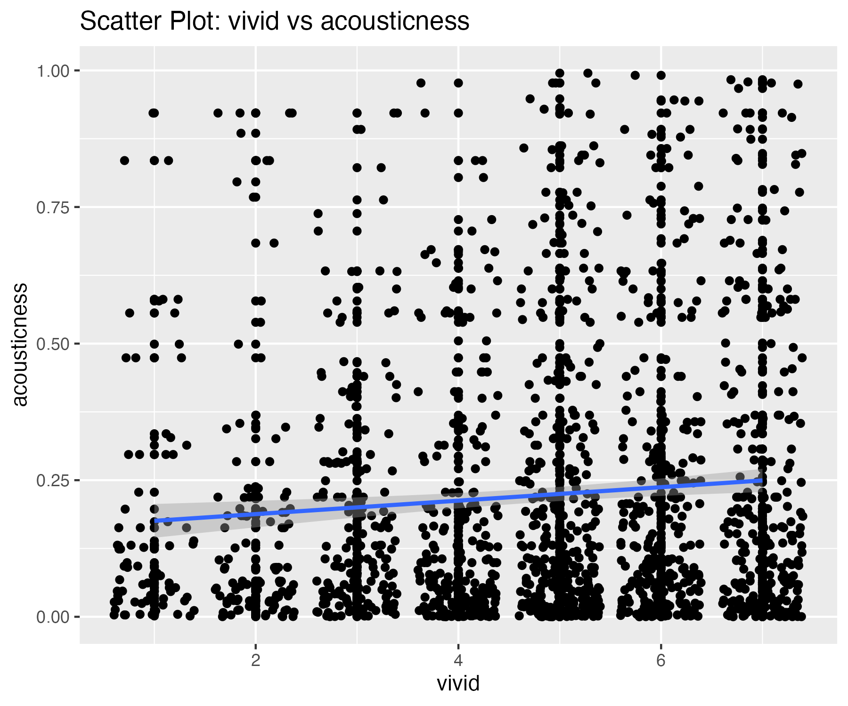

0 outliers were identified in the acousticness variable.

## Scatterplot of acousticness variable with outliers removed

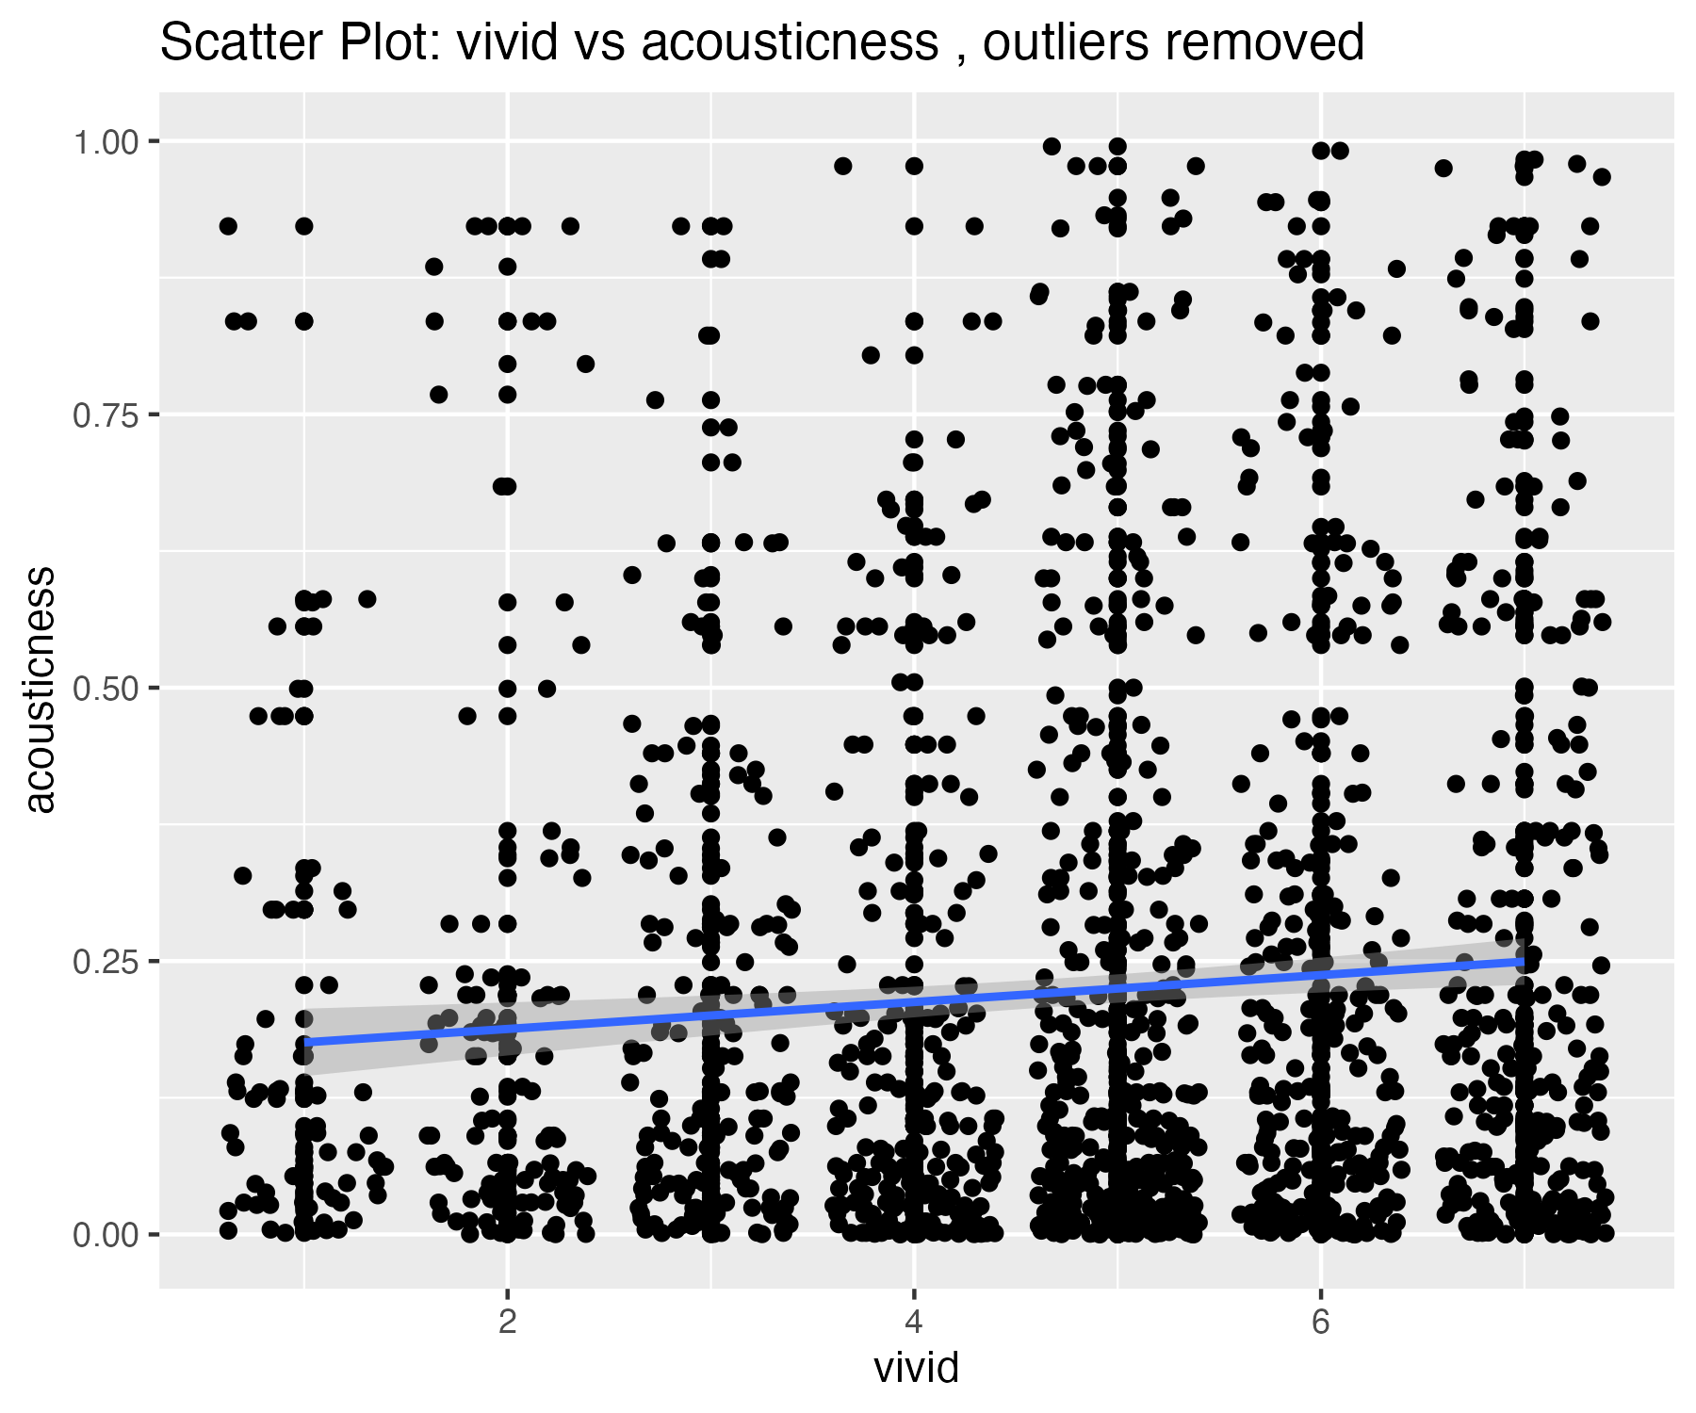

## Plots for instrumentalness variable

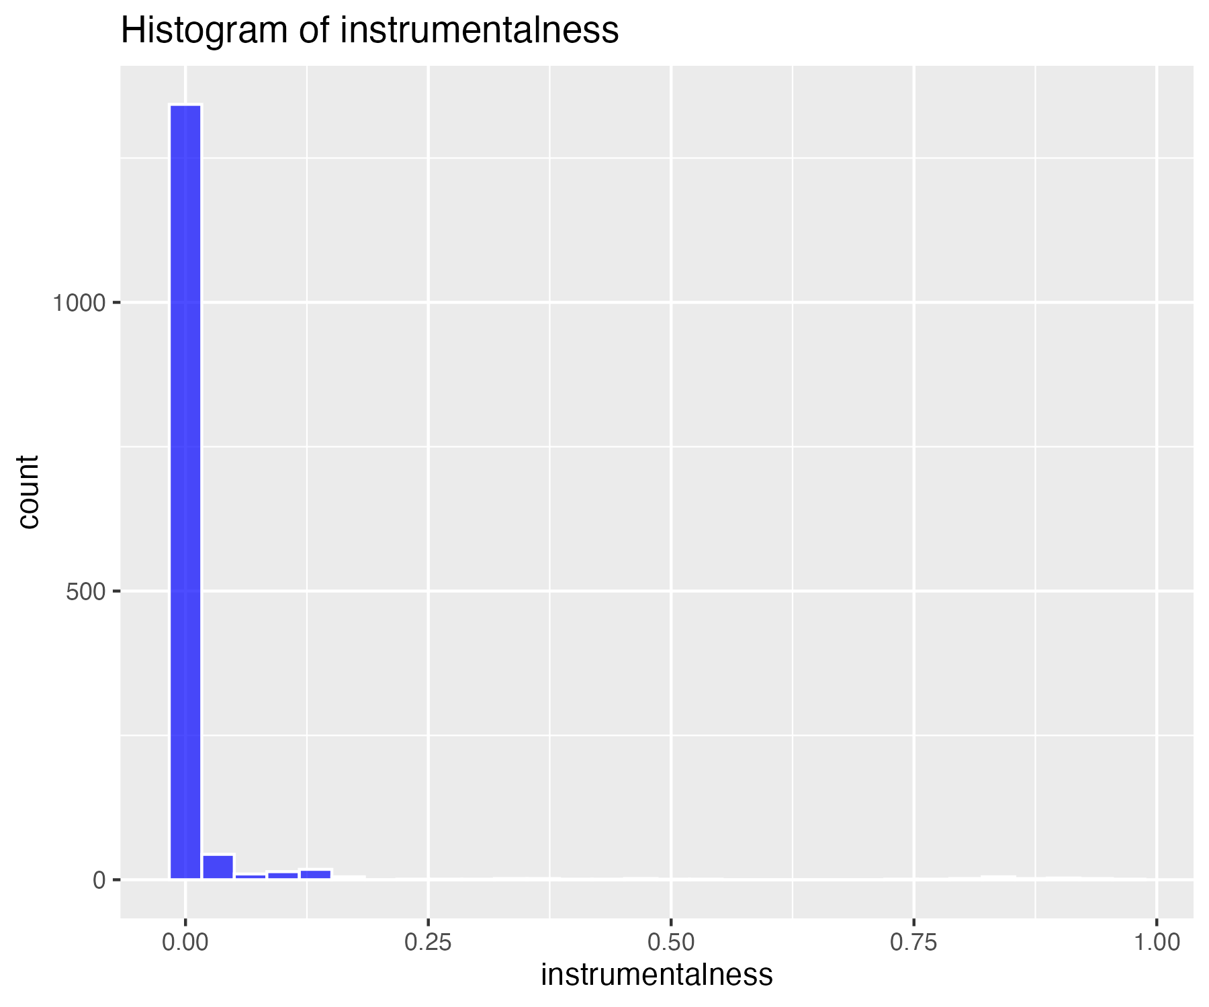

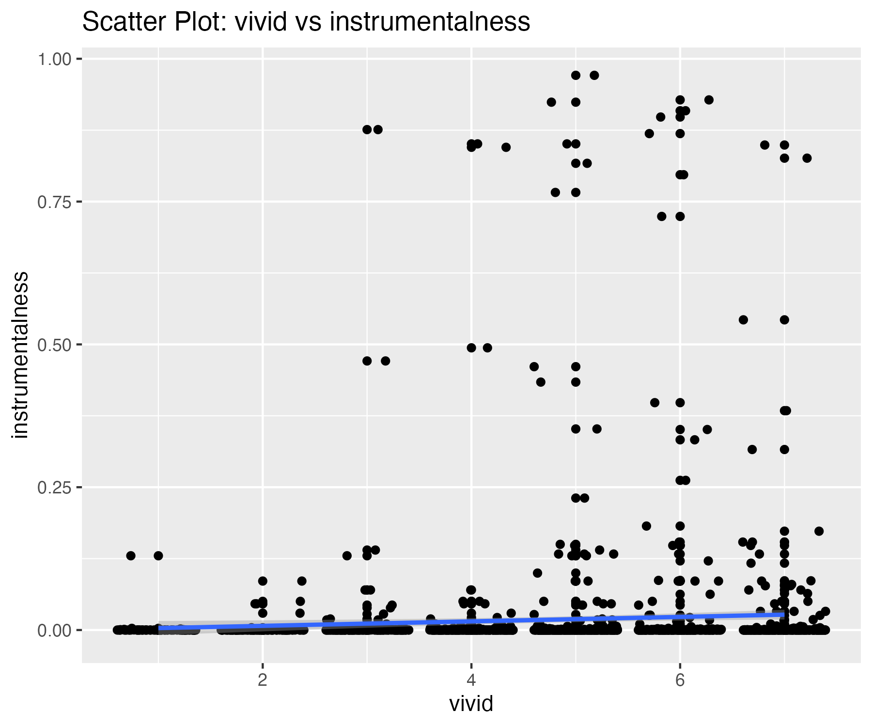

26 outliers were identified in the instrumentalness variable.

## Scatterplot of instrumentalness variable with outliers removed

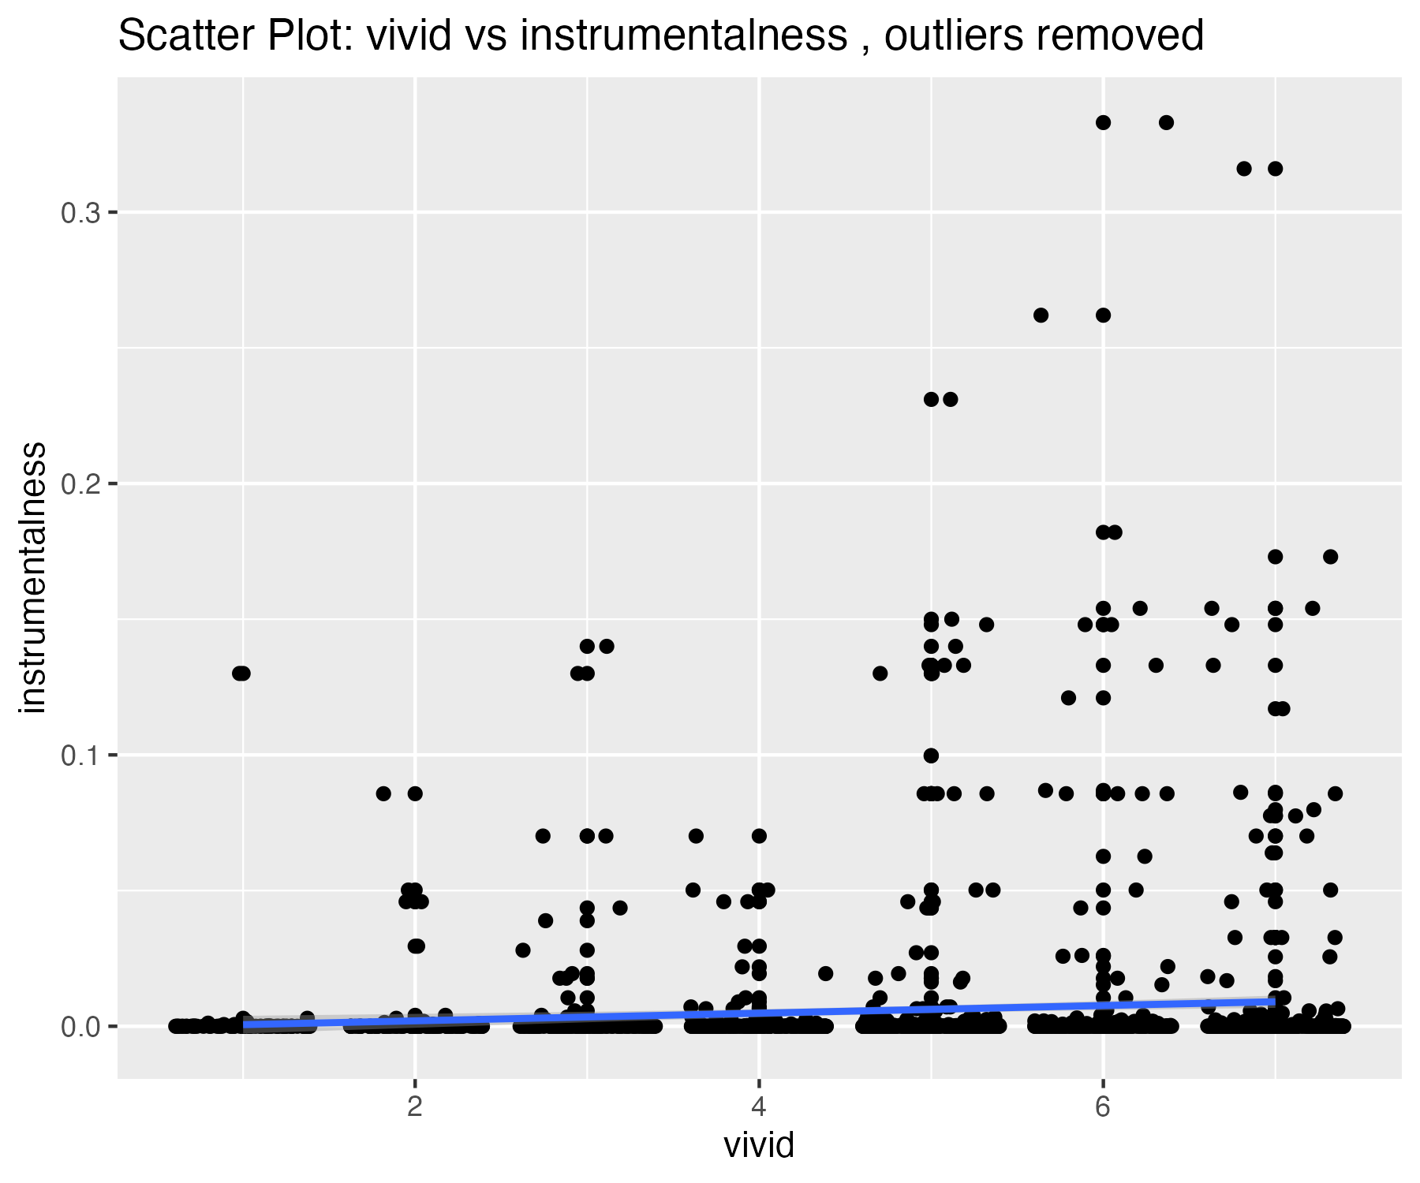

## Plots for liveness variable

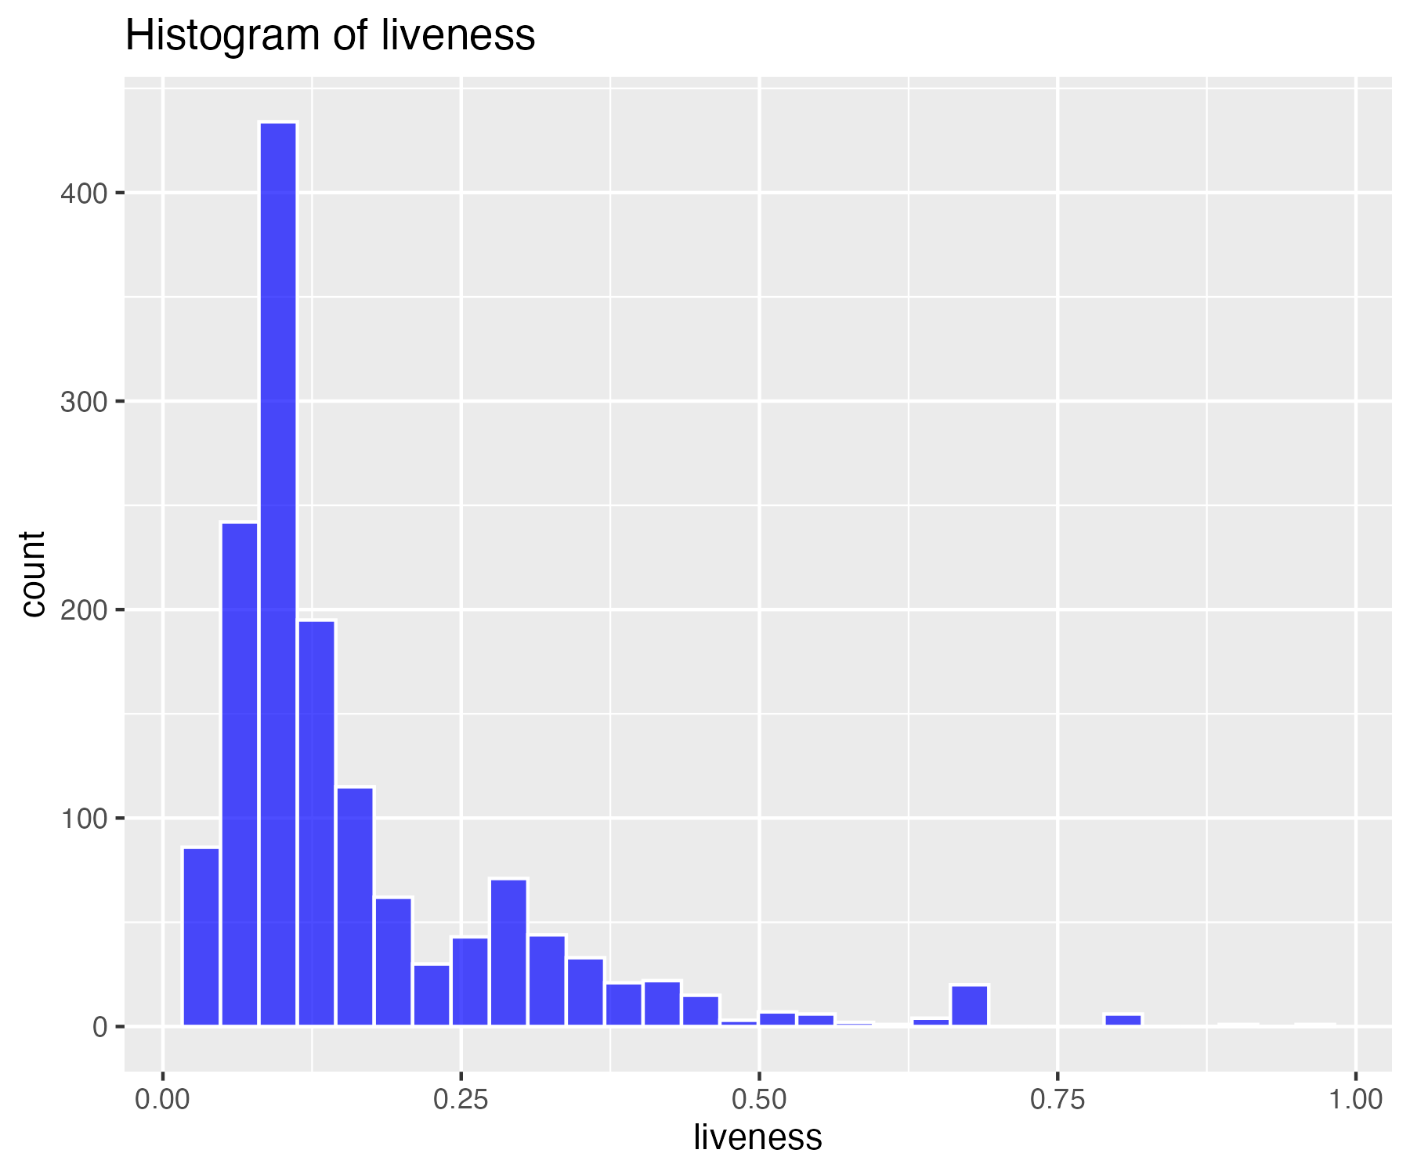

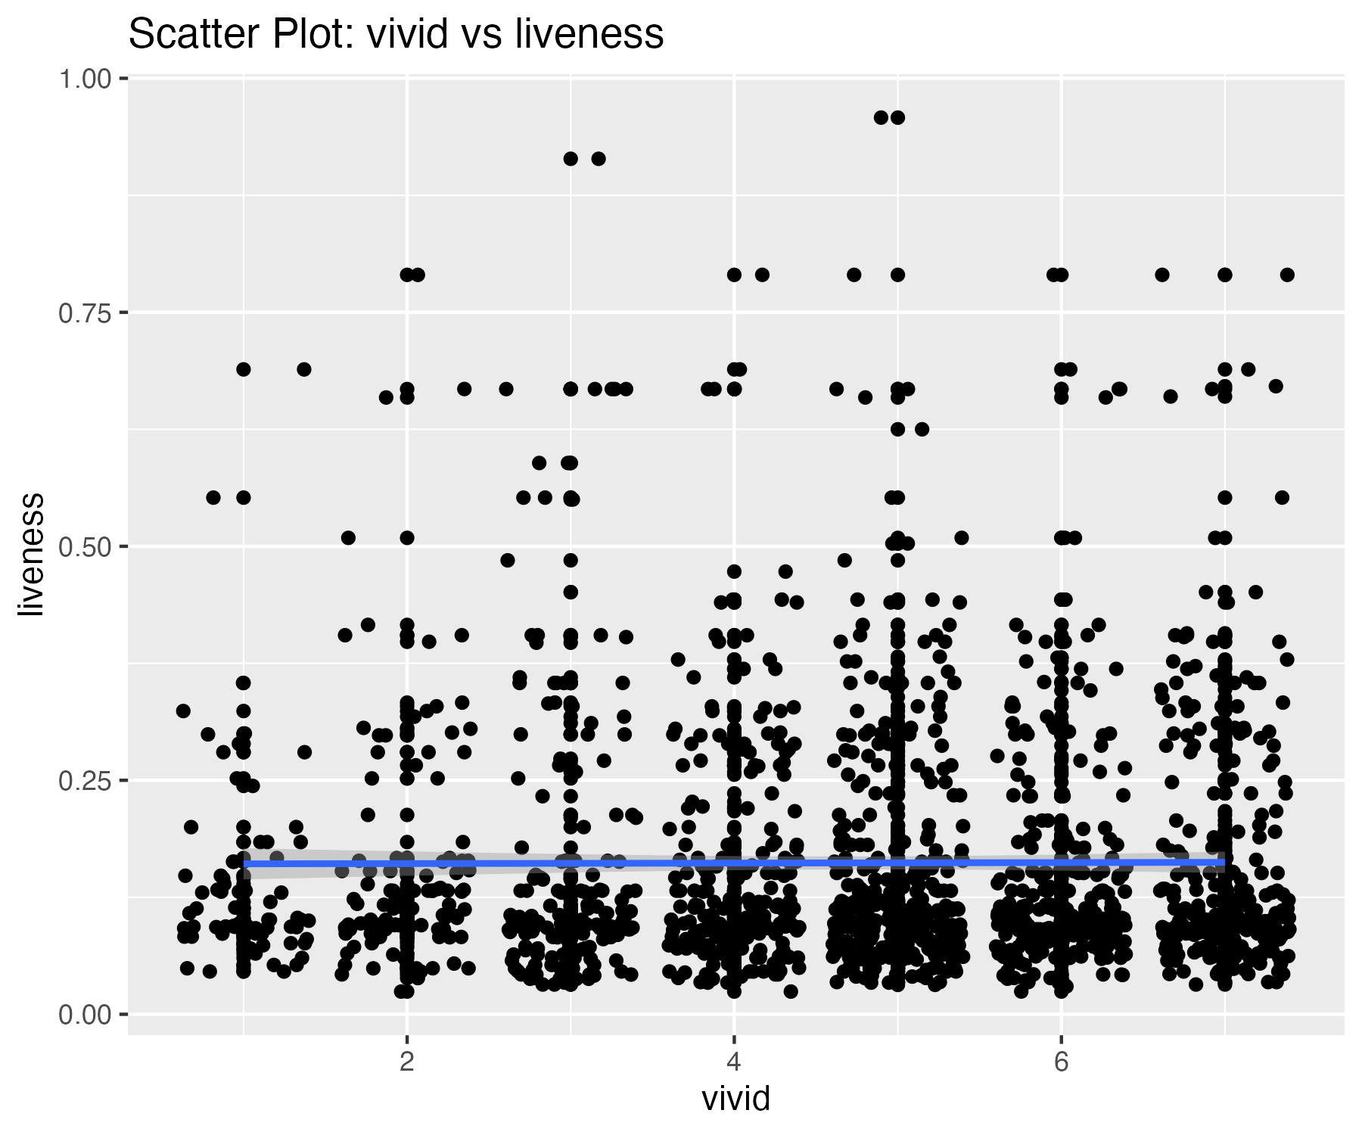

33 outliers were identified in the liveness variable.

## Scatterplot of liveness variable with outliers removed

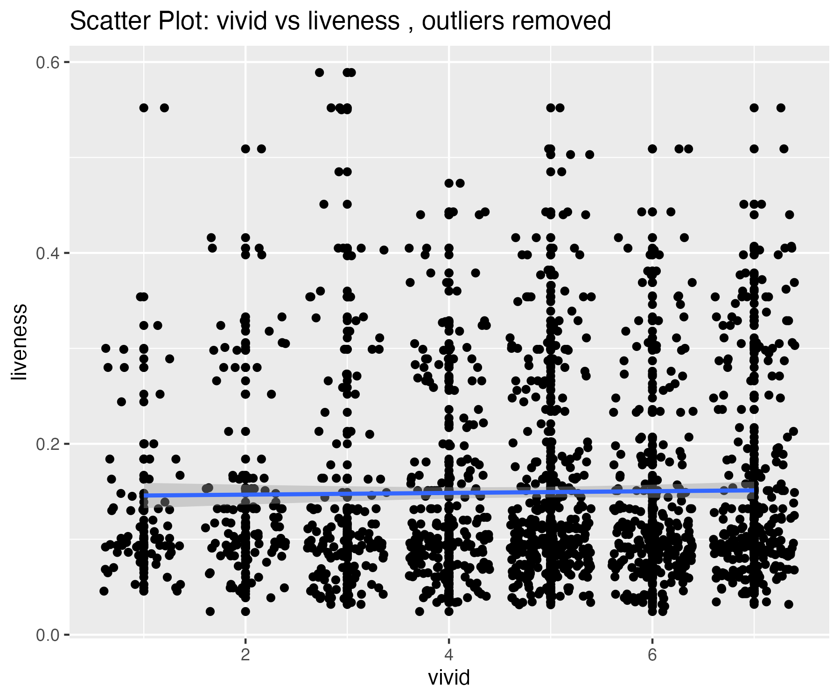

## Plots for valence variable

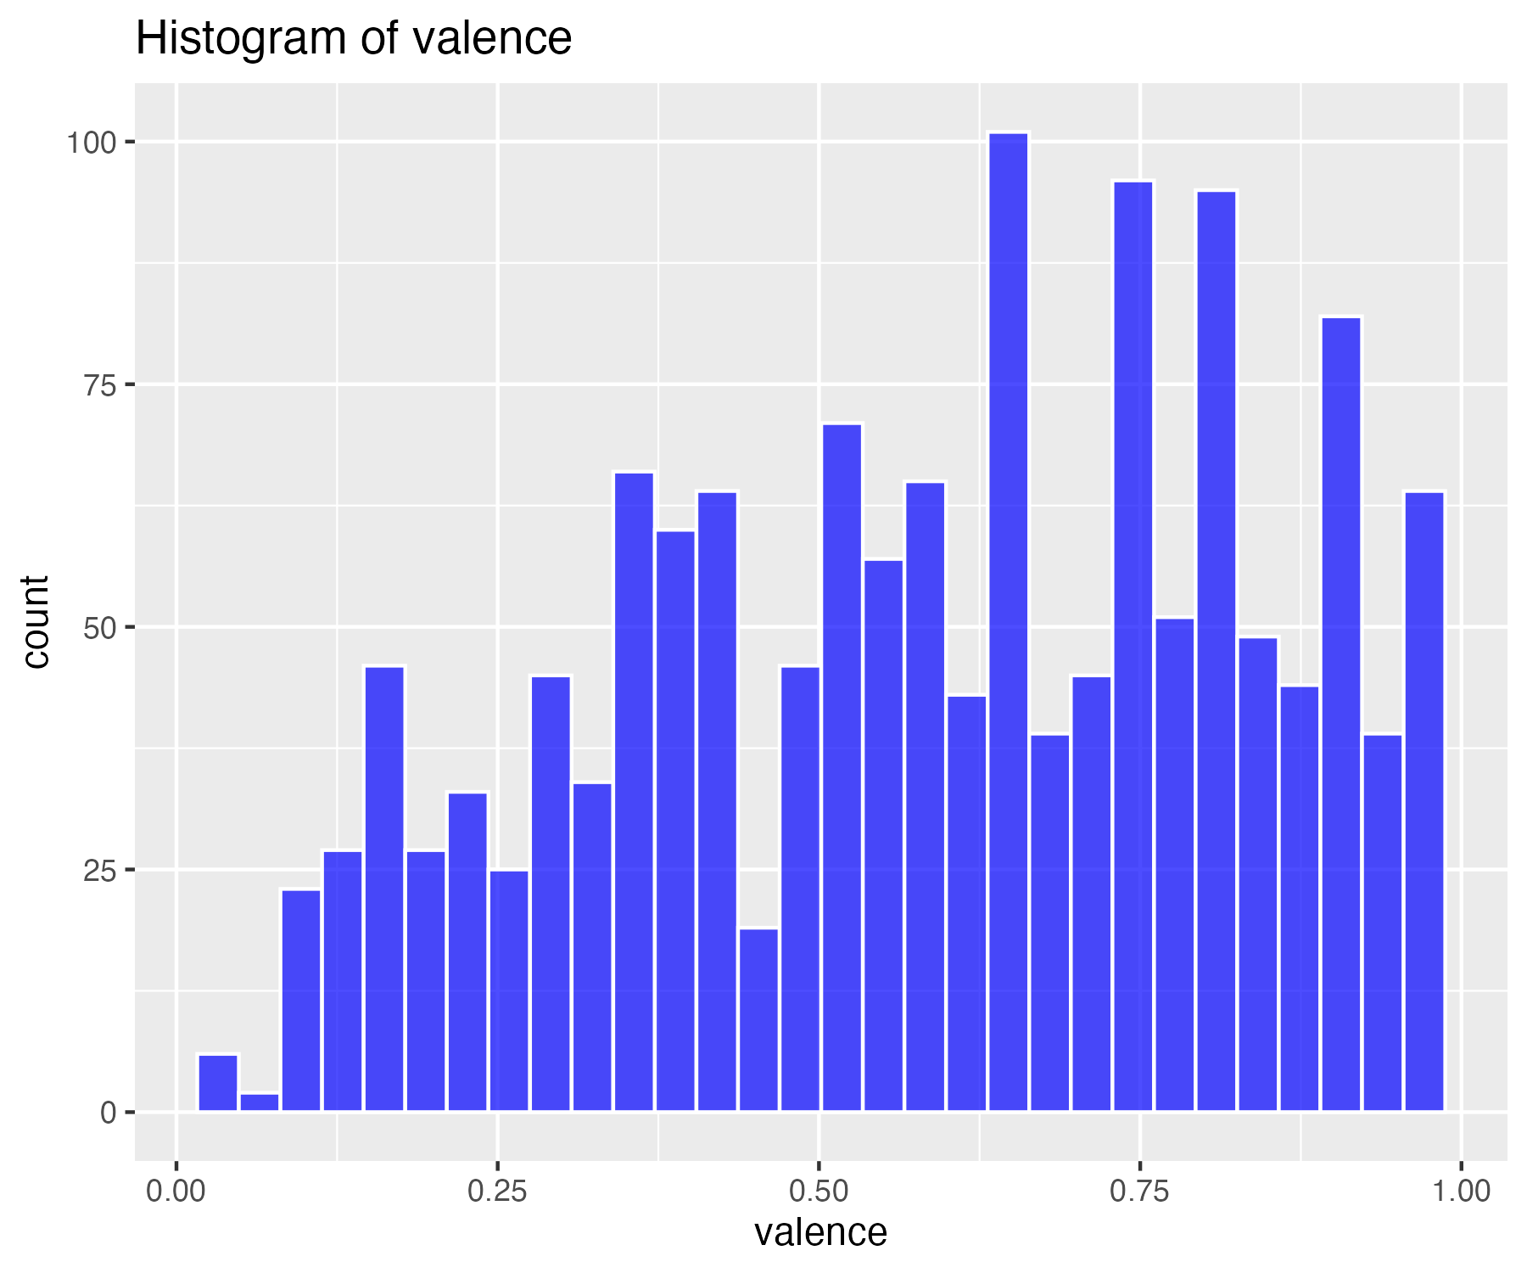

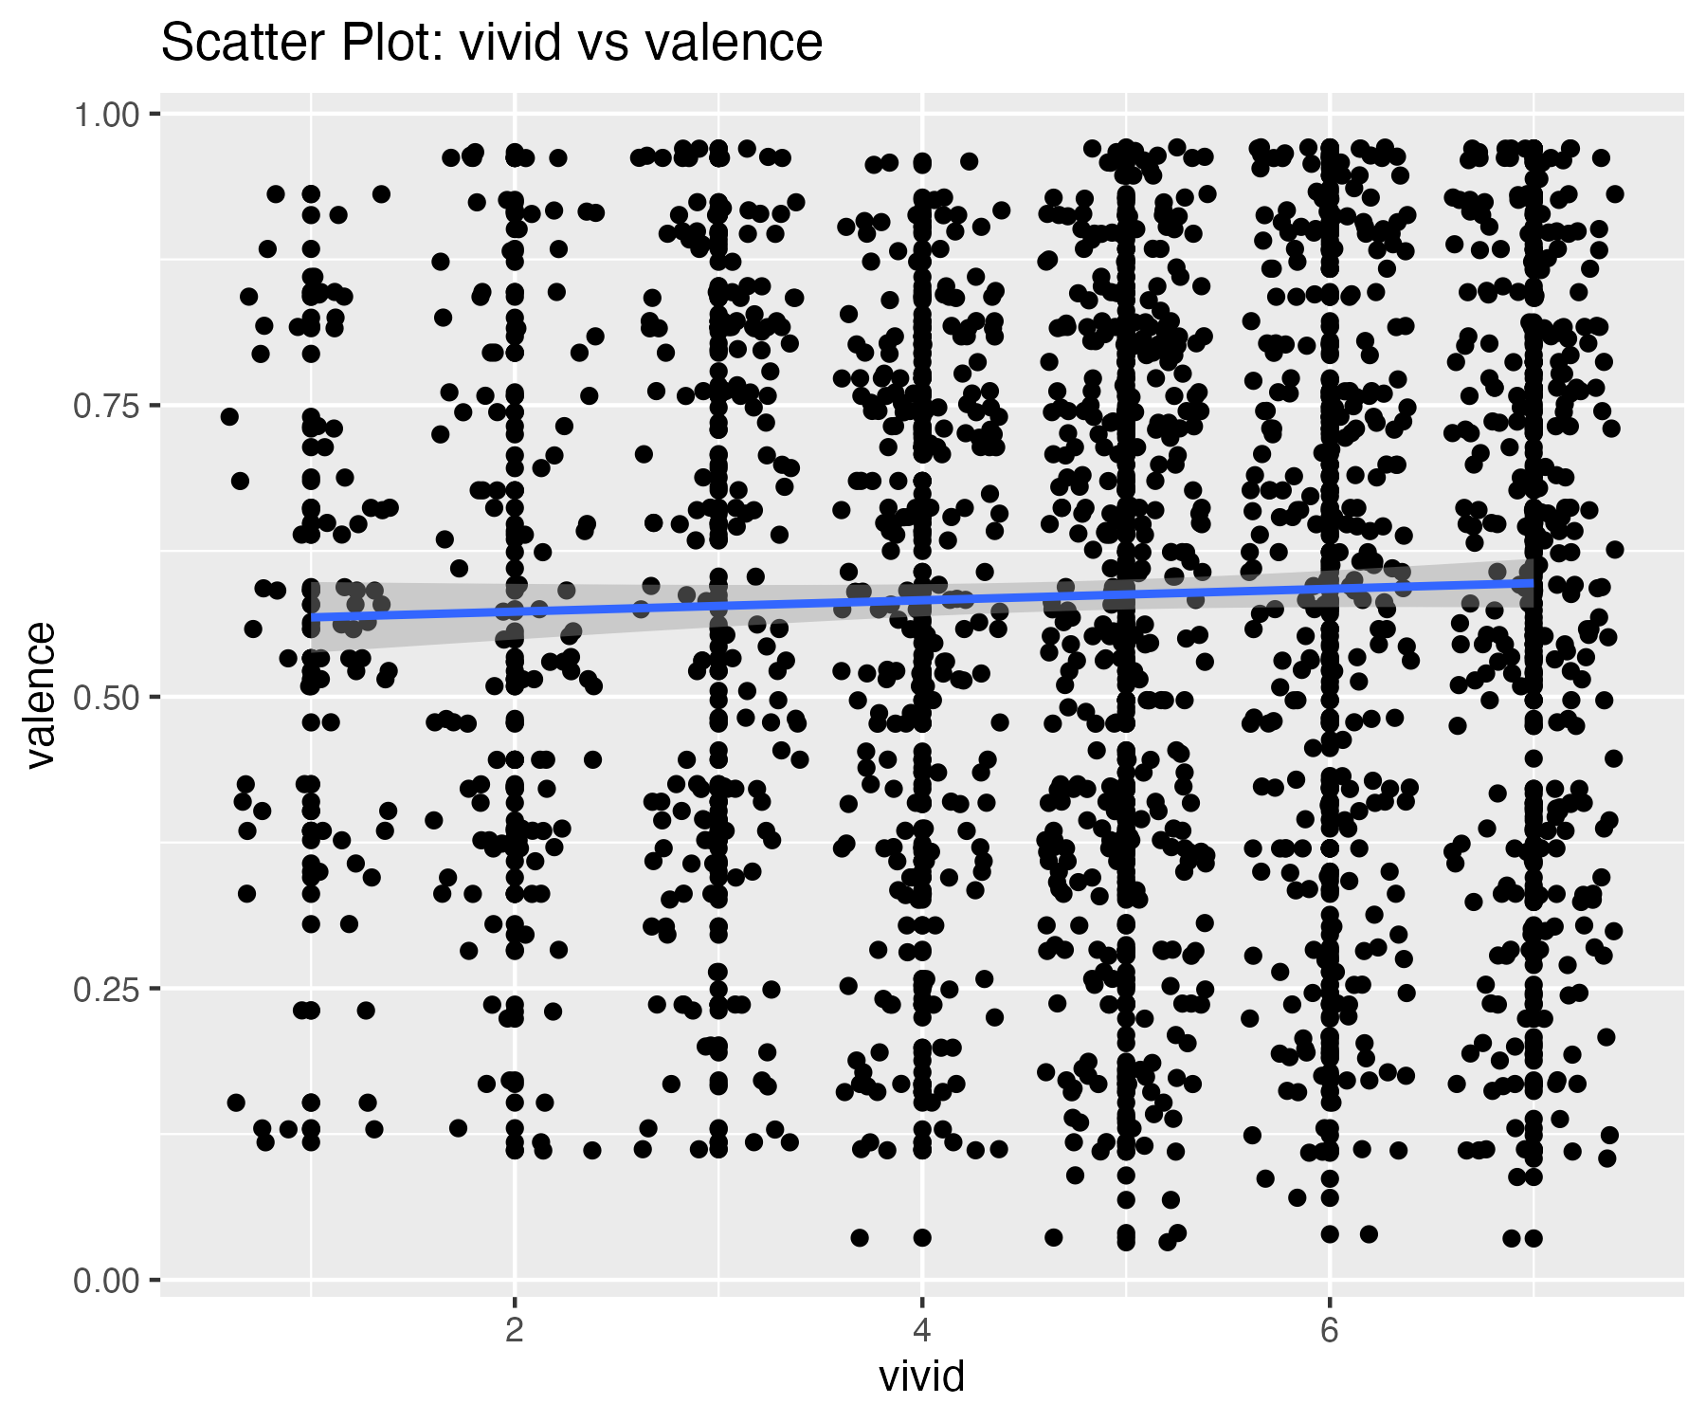

0 outliers were identified in the valence variable.

## Scatterplot of valence variable with outliers removed

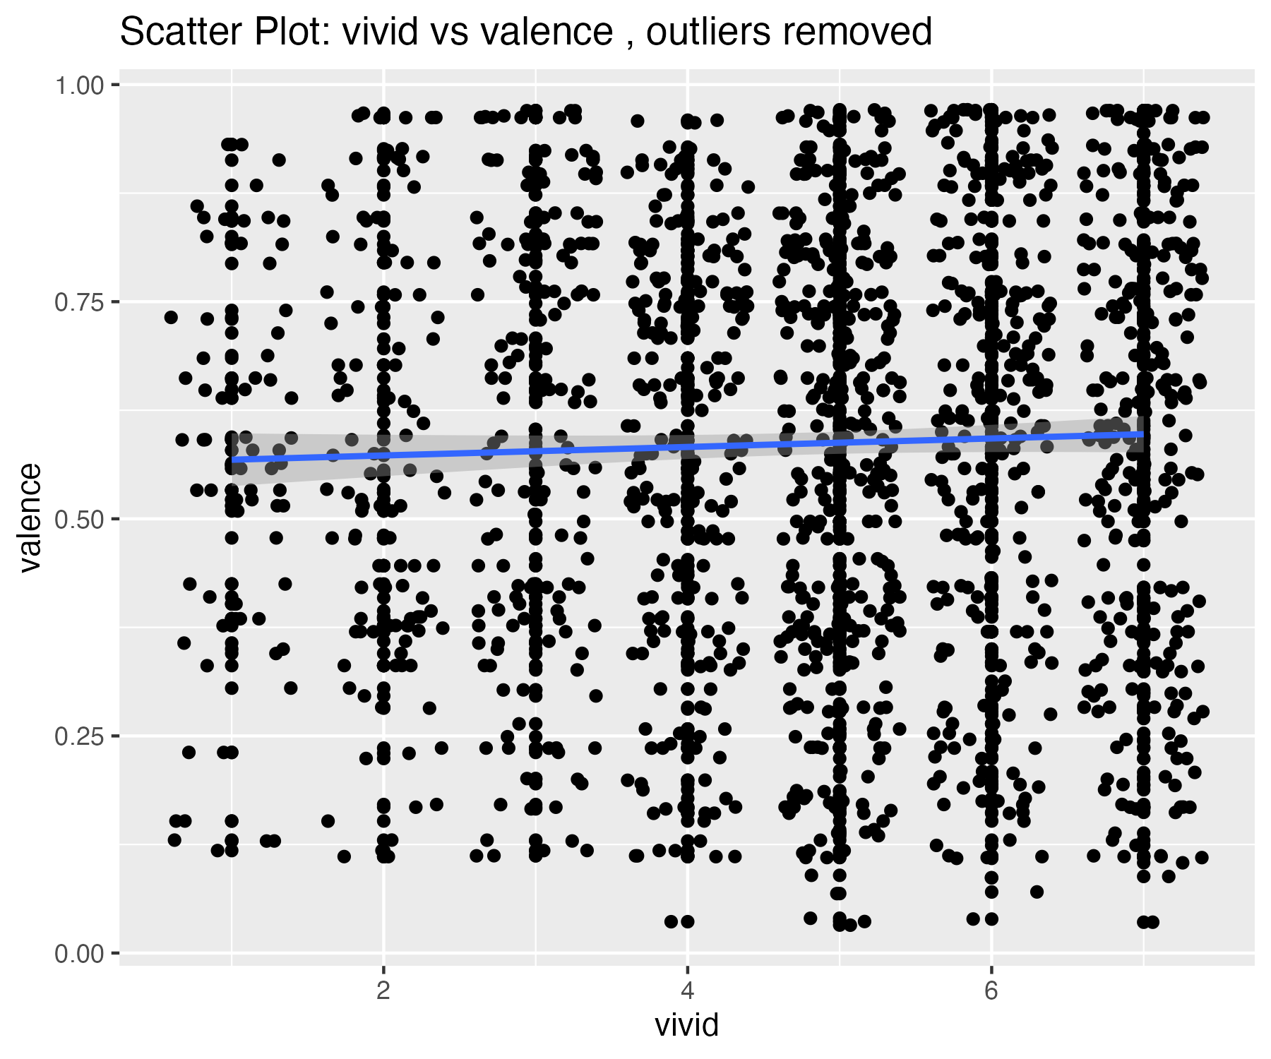

## Plots for tempo variable

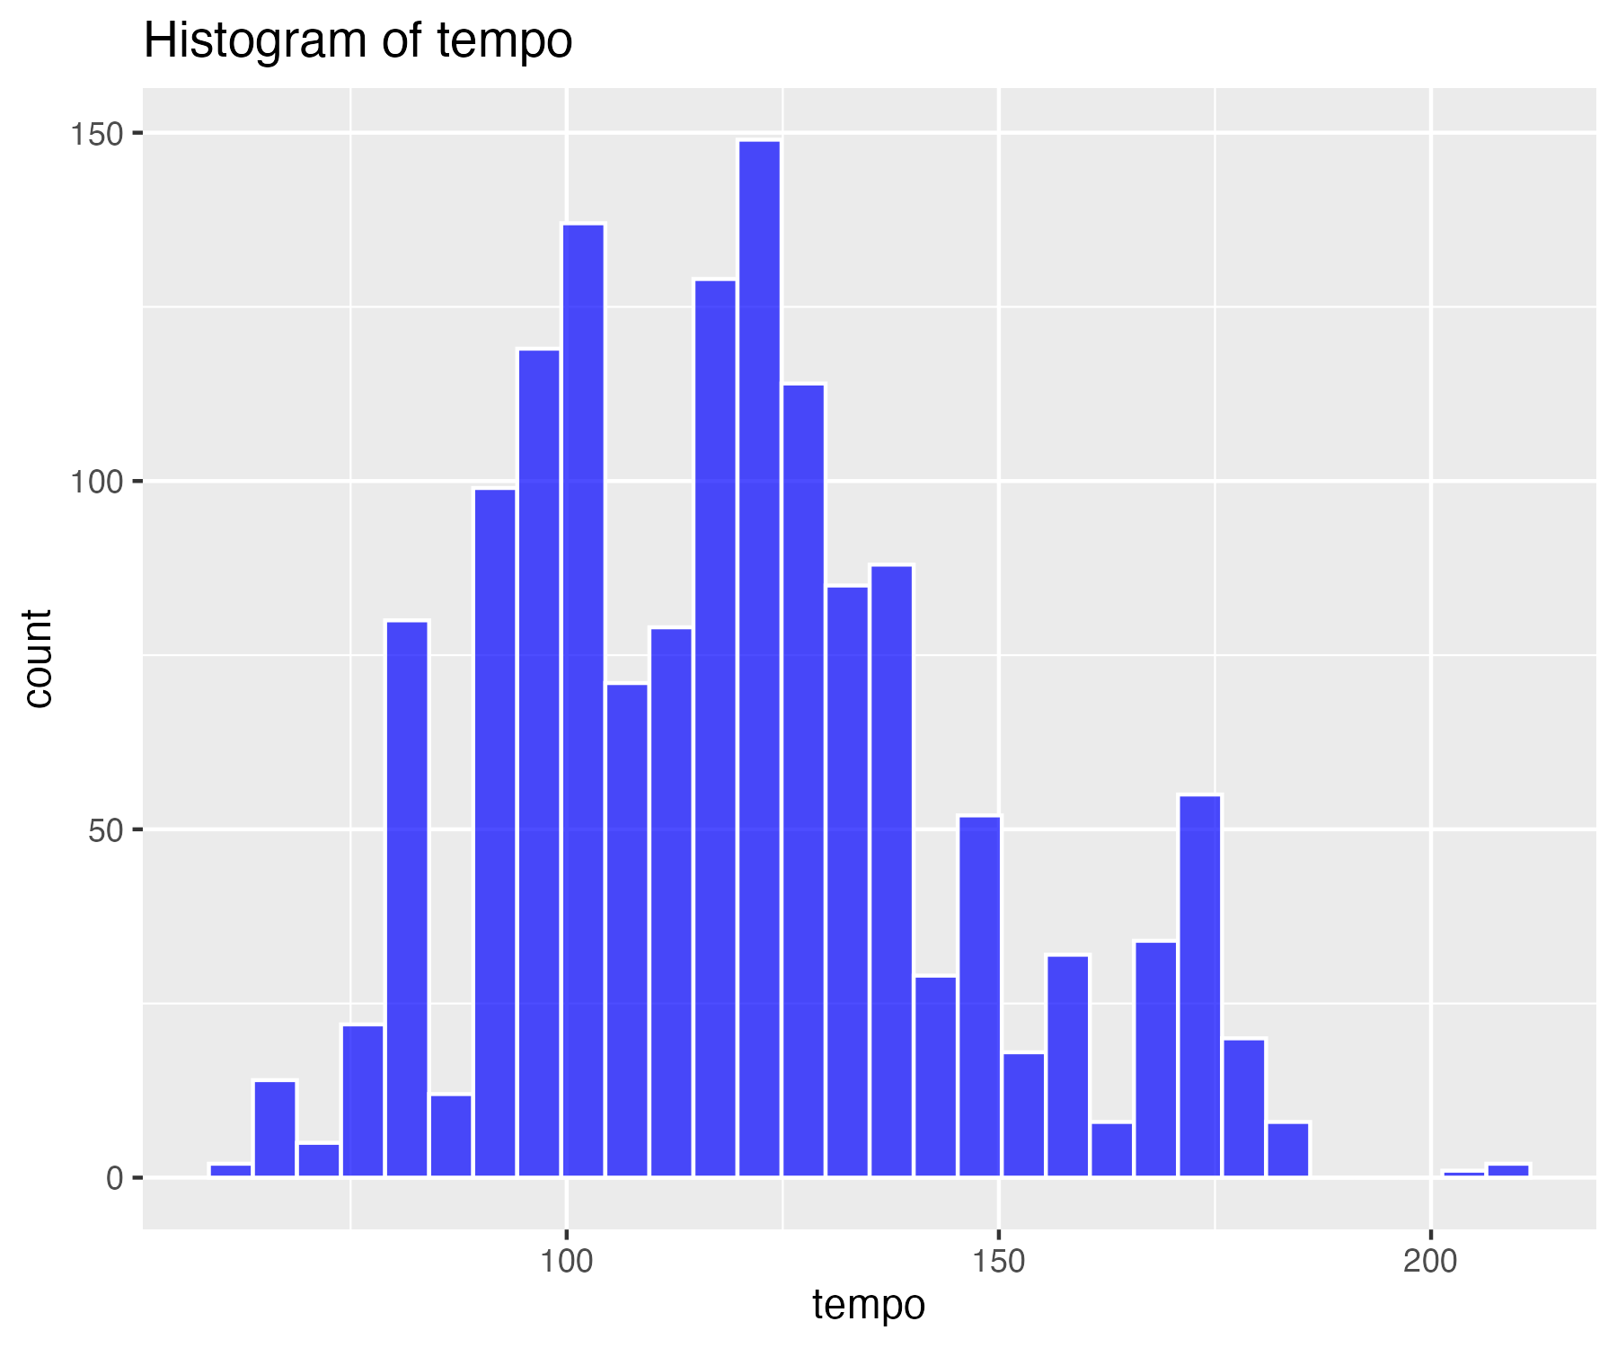

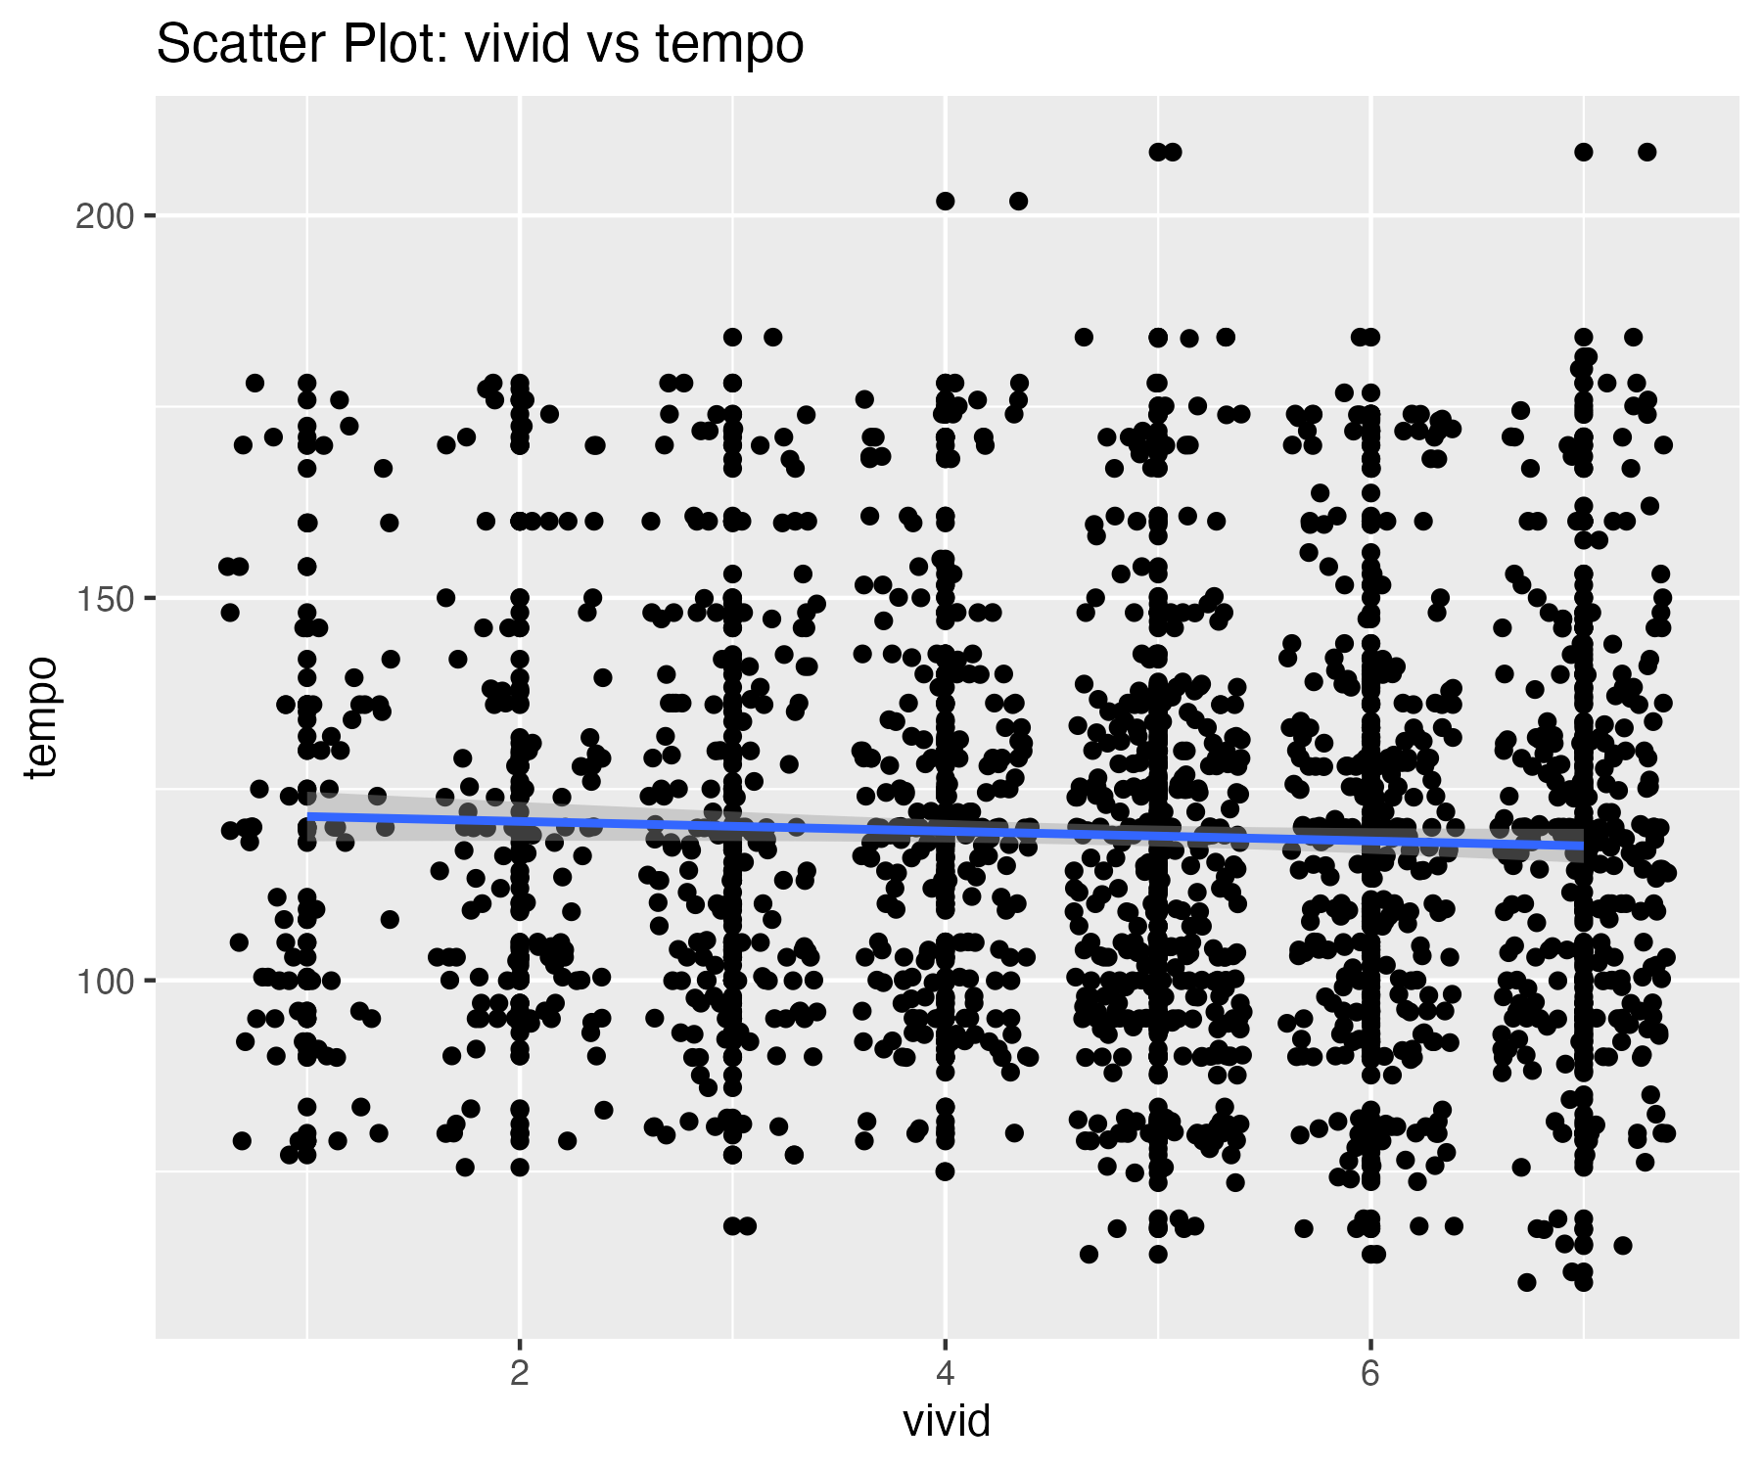

2 outliers were identified in the tempo variable.

## Scatterplot of tempo variable with outliers removed

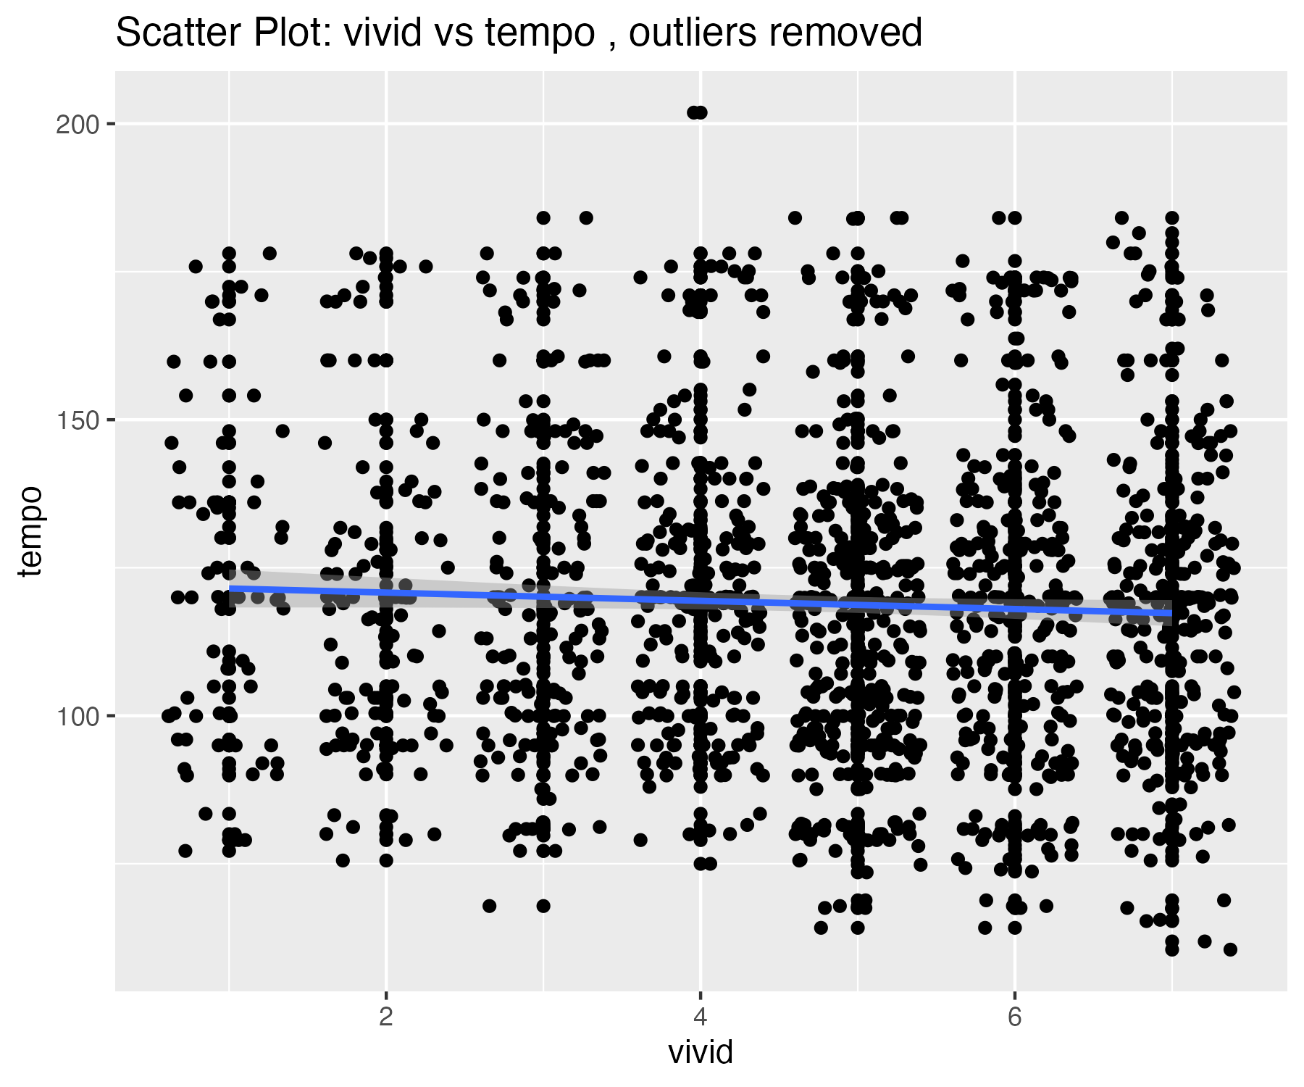

## Descriptives summary table for all variables

| matrix.nrow...20..ncol...1. | danceability | energy | loudness | speechiness | acousticness | instrumentalness | liveness | valence | tempo |
| --- | --- | --- | --- | --- | --- | --- | --- | --- | --- |
| nbr.val | 1,464.00 | 1,464.00 | 1,464.00 | 1,464.00 | 1,464.00 | 1,464.00 | 1,464.00 | 1,464.00 | 1,464.00 |
| nbr.null | 0.00 | 0.00 | 0.00 | 0.00 | 0.00 | 723.00 | 0.00 | 0.00 | 0.00 |
| nbr.na | 0.00 | 0.00 | 0.00 | 0.00 | 0.00 | 0.00 | 0.00 | 0.00 | 0.00 |
| min | 0.15 | 0.01 | -25.27 | 0.02 | 0.00 | 0.00 | 0.02 | 0.03 | 60.49 |
| max | 0.96 | 0.99 | -1.60 | 0.44 | 1.00 | 0.97 | 0.96 | 0.97 | 208.28 |
| range | 0.81 | 0.98 | 23.67 | 0.42 | 0.99 | 0.97 | 0.93 | 0.94 | 147.79 |
| sum | 975.50 | 937.14 | -10,709.35 | 104.62 | 324.23 | 26.87 | 235.99 | 859.70 | 174,361.54 |
| median | 0.68 | 0.66 | -6.55 | 0.04 | 0.13 | 0.00 | 0.11 | 0.61 | 118.98 |
| mean | 0.67 | 0.64 | -7.32 | 0.07 | 0.22 | 0.02 | 0.16 | 0.59 | 119.10 |
| SE.mean | 0.00 | 0.00 | 0.09 | 0.00 | 0.01 | 0.00 | 0.00 | 0.01 | 0.68 |
| CI.mean.0.95 | 0.01 | 0.01 | 0.17 | 0.00 | 0.01 | 0.01 | 0.01 | 0.01 | 1.33 |
| var | 0.02 | 0.03 | 10.68 | 0.00 | 0.06 | 0.01 | 0.02 | 0.06 | 676.50 |
| std.dev | 0.15 | 0.18 | 3.27 | 0.07 | 0.25 | 0.10 | 0.13 | 0.24 | 26.01 |
| coef.var | 0.22 | 0.28 | -0.45 | 0.94 | 1.12 | 5.49 | 0.83 | 0.42 | 0.22 |
| skewness | -0.57 | -0.50 | -1.44 | 2.92 | 1.36 | 7.39 | 2.20 | -0.27 | 0.49 |
| skew.2SE | -4.47 | -3.89 | -11.23 | 22.82 | 10.63 | 57.74 | 17.22 | -2.14 | 3.82 |
| kurtosis | 0.13 | -0.15 | 3.09 | 10.04 | 0.93 | 57.17 | 5.75 | -0.98 | -0.11 |
| kurt.2SE | 0.53 | -0.59 | 12.10 | 39.27 | 3.63 | 223.62 | 22.50 | -3.83 | -0.44 |
| normtest.W | 0.98 | 0.98 | 0.90 | 0.64 | 0.81 | 0.18 | 0.75 | 0.96 | 0.97 |
| normtest.p | 0.00 | 0.00 | 0.00 | 0.00 | 0.00 | 0.00 | 0.00 | 0.00 | 0.00 |

## Descriptives summary table for all variables with outliers removed

| matrix.nrow...20..ncol...1. | danceability | energy | loudness | speechiness | acousticness | instrumentalness | liveness | valence | tempo |
| --- | --- | --- | --- | --- | --- | --- | --- | --- | --- |
| nbr.val | 1,459.00 | 1,460.00 | 1,446.00 | 1,417.00 | 1,464.00 | 1,438.00 | 1,431.00 | 1,464.00 | 1,462.00 |
| nbr.null | 0.00 | 0.00 | 0.00 | 0.00 | 0.00 | 723.00 | 0.00 | 0.00 | 0.00 |
| nbr.na | 0.00 | 0.00 | 0.00 | 0.00 | 0.00 | 0.00 | 0.00 | 0.00 | 0.00 |
| min | 0.21 | 0.08 | -17.85 | 0.02 | 0.00 | 0.00 | 0.02 | 0.03 | 60.49 |
| max | 0.96 | 0.99 | -1.60 | 0.26 | 1.00 | 0.33 | 0.59 | 0.97 | 201.87 |
| range | 0.75 | 0.91 | 16.25 | 0.24 | 0.99 | 0.33 | 0.56 | 0.94 | 141.38 |
| sum | 974.73 | 937.05 | -10,336.61 | 88.01 | 324.23 | 8.37 | 212.67 | 859.70 | 173,944.98 |
| median | 0.68 | 0.66 | -6.55 | 0.04 | 0.13 | 0.00 | 0.11 | 0.61 | 118.98 |
| mean | 0.67 | 0.64 | -7.15 | 0.06 | 0.22 | 0.01 | 0.15 | 0.59 | 118.98 |
| SE.mean | 0.00 | 0.00 | 0.08 | 0.00 | 0.01 | 0.00 | 0.00 | 0.01 | 0.68 |
| CI.mean.0.95 | 0.01 | 0.01 | 0.15 | 0.00 | 0.01 | 0.00 | 0.01 | 0.01 | 1.32 |
| var | 0.02 | 0.03 | 8.49 | 0.00 | 0.06 | 0.00 | 0.01 | 0.06 | 666.53 |
| std.dev | 0.15 | 0.18 | 2.91 | 0.04 | 0.25 | 0.03 | 0.11 | 0.24 | 25.82 |
| coef.var | 0.22 | 0.28 | -0.41 | 0.69 | 1.12 | 4.48 | 0.71 | 0.42 | 0.22 |
| skewness | -0.50 | -0.44 | -0.91 | 1.75 | 1.36 | 6.50 | 1.54 | -0.27 | 0.46 |
| skew.2SE | -3.86 | -3.41 | -7.06 | 13.48 | 10.63 | 50.39 | 11.88 | -2.14 | 3.58 |
| kurtosis | -0.11 | -0.34 | 0.38 | 2.76 | 0.93 | 52.68 | 1.82 | -0.98 | -0.21 |
| kurt.2SE | -0.42 | -1.35 | 1.49 | 10.61 | 3.63 | 204.24 | 7.04 | -3.83 | -0.81 |
| normtest.W | 0.98 | 0.98 | 0.94 | 0.77 | 0.81 | 0.24 | 0.81 | 0.96 | 0.97 |
| normtest.p | 0.00 | 0.00 | 0.00 | 0.00 | 0.00 | 0.00 | 0.00 | 0.00 | 0.00 |